**INTERNATIONAL HYDROGRAPHIC ORGANIZATION**



**IHO GEOSPATIAL STANDARD**

**FOR MARINE PROTECTED AREAS**

**Working Draft – xxxxx 2015**

**Special Publication No. S-122**

Marine Protected Areas - Product Specification

**Published by the   
International Hydrographic Organization  
MONACO**

Blank Page

© Copyright International Hydrographic Organization 2014

This work is copyright. Apart from any use permitted in accordance with the Berne

Convention for the Protection of Literary and Artistic Works (1886), and except in the circumstances described below, no part may be translated, reproduced by any process, adapted, communicated or commercially exploited without prior written permission from the International Hydrographic Bureau (IHB). Copyright in some of the material in this publication may be owned by another party and permission for the translation and/or reproduction of that material must be obtained from the owner.

This document or partial material from this document may be translated, reproduced or distributed for general information, on no more than a cost recovery basis. Copies may not be sold or distributed for profit or gain without prior written agreement of the IHB and any other copyright holders.

In the event that this document or partial material from this document is reproduced, translated or distributed under the terms described above, the following statements are to be included:

*“Material from IHO publication [reference to extract: Title, Edition] is reproduced with the permission of the International Hydrographic Bureau (IHB) (Permission No ……./…) acting for the International Hydrographic Organization (IHO), which does not accept responsibility for the correctness of the material as reproduced: in case of doubt, the IHO’s authentic text shall prevail. The incorporation of material sourced from IHO shall not be construed as constituting an endorsement by IHO of this product.”*

*“This [document/publication] is a translation of IHO [document/publication] [name].*

*The IHO has not checked this translation and therefore takes no responsibility for its accuracy. In case of doubt the source version of [name] in [language] should be consulted.”*

The IHO Logo or other identifiers shall not be used in any derived product without prior written permission from the IHB.

**Revision History**

Changes to this Product Specification are coordinated by the IHO Nautical Information Provision Working Group (NIPWG). New editions will be made available via the IHO web site. Maintenance of the Product Specification shall conform to IHO Technical Resolution 2/2007 (revised 2010).

|  |  |  |  |
| --- | --- | --- | --- |
| **Version Number** | **Date** | **Author** | **Purpose** |
|  |  |  |  |
|  |  |  |  |
|  |  |  |  |
|  |  |  |  |
|  |  |  |  |
|  |  |  |  |
|  |  |  |  |
|  |  |  |  |
|  |  |  |  |
|  |  |  |  |
|  |  |  |  |
|  |  |  |  |

**TABLE OF CONTENTS**

1 Overview 1

1.1 Introduction 1

2 References 2

2.1 Normative 2

2.2 Informative 2

2.3 Terms, Definitions and Abbreviations 2

2.3.1 Terms and Definitions 2

2.3.2 Abbreviations 4

2.4 Use of Language 5

3 General Data Product Description 7

3.1 Specification Scope 7

3.2 Product Identification 7

3.3 Product Specification Maintenance 8

3.3.1 Introduction 8

3.3.2 New Edition 8

3.3.3 Revisions 8

3.3.4 Clarification 8

3.3.5 Version Numbers 8

4 Data Content and Structure 9

4.1 Introduction 9

4.2 Application Schema 9

4.3 Feature Catalogue 10

4.3.1 Introduction 10

4.4 Feature Types 10

4.4.1 Geographic 10

4.4.2 Meta 10

4.4.3 Feature Relationship 11

4.4.4 Information Types 11

4.4.5 Attributes 11

4.5 Dataset Loading and Unloading 12

4.6 Geometric Representation 12

4.7 Coordinate Reference System (CRS) 13

4.7.1 Introduction 13

4.7.2 Horizontal reference system 14

4.7.3 Projection 14

4.7.4 Vertical coordinate reference system 14

4.7.5 Temporal reference system 14

5 Data Quality 15

5.1 Introduction 15

5.2 Completeness 15

5.3 Test Case for MPA Geometry 15

5.4 Test Case for extra data 15

5.5 Test Case for empty data 15

5.6 Logical Consistency 15

5.7 Conceptual Consistency 16

5.8 Domain Consistency 16

5.9 Test Case 16

5.10 Format Consistency 16

5.11 Test Case 16

5.12 Positional Accuracy 16

5.13 Test Case 16

5.14 Temporal Accuracy 17

5.15 Thematic Accuracy 17

5.15.1 Thematic Classification Correctness 17

5.16 Non Quantitative Attribute Accuracy 17

5.17 Quantitative Attribute Accuracy 17

6 Data Capture and Classification 19

6.1 Data Encoding and Product Delivery 19

6.1.1 Data Encoding 19

6.1.2 Data Product Delivery Information 19

6.1.3 Exchange Set 20

6.1.4 Support Files 20

6.1.5 Support File Naming Convention 21

6.1.6 Dataset Naming Convention 21

6.1.7 Catalogue File Naming Convention 21

6.1.8 Dataset Maintenance 22

7 Portrayal 23

8 Metadata 24

8.1 Introduction 24

8.2 Dataset Metadata 24

8.3 Exchange Set Metadata 26

8.4 Catalogue File Metadata. 26

Annex A 1

Annex B 14

# Overview

A Marine Protected Area (MPA) is a protected area whose boundaries include an area of ocean. They include areas of the intertidal or sub-tidal terrain, together with their overlying water and associated flora, fauna, historical and cultural features, which have been reserved by law or other effective means to protect part or all of, the enclosed environment.For example, MPAs may be established to protect fish species, rare habitat area, or entire ecosystems.

MPAs can range from, simple declarations to protect a resource, to areas that are extensively regulated. The degree to which environmental regulations affect shipping varies according to whether MPAs are located in territorial waters, exclusive economic zones, or high seas. These limits are regulated by the law of the sea. Most MPAs are located in the territorial waters of coastal states, where enforcement can be ensured. MPAs can also however be established in a state's exclusive economic zone and even within international waters. For example in 1999, Italy, France and Monaco jointly established a cetacean sanctuary in the Ligurian Sea named the Pelagos Sanctuary for Mediterranean Marine Mammals. This sanctuary includes both national and international waters.

## Introduction

This document has been produced by the IHO Nautical Information Provision Working Group in response to a requirement to produce a data product that can be used as a Nautical Publication Overlay (NPIO) within an Electronic Chart Display and Information Systems. It is based on the IHO S-100 framework specification and the ISO 19100 series of standards. It is a vector product specification that is primarily intended for encoding the extent and nature of Marine Protected Areas, for navigational purposes.

The United Nations Convention on the Law of the Sea (UNCLOS) identifies certain categories of Marine Protected Areas which may require higher standards of environmental protection. Article 194(5) places an obligation on parties to take measures necessary to protect and preserve rare or fragile ecosystems. Part IX of UNCLOS identifies enclosed or semi-enclosed areas, such as a gulf, bay, basin or sea between two or more countries, as places where countries shall endeavor to coordinate the management of environmental protection activities. In respect of Particularly Sensitive Sea Areas (PSSA), Article 211(6)(a) UNCLOS makes provision for a State to submit to the “competent international organization” (IMO for shipping), special mandatory measures concerning the protection from vessel sourced pollution.

UNCLOS thus creates an overall structure for the protection and preservation of the marine environment and places a general obligation on States to implement global conventions addressing particular forms of pollution protection and regional agreements tailored to the requirements of discrete sea areas.

# References

## Normative

The following normative documents contain provisions that, through reference in this text, constitute provisions of this document.

IHO S-100 IHO Universal Hydrographic Data Model Edition 2.0 (June 2015).

ISO 8601. 2004. *Data elements and interchange formates - Information interchange - Representation of dates and times.* 2004.

ISO 3166-1. 1997**.** *Country Codes.* 1997.

ISO 19101-2:2008 Geographic Information - Rules for Application Schema

ISO/TS 19103:2005 Geographic Information - Conceptual schema language

ISO 19106:2004 Geographic Information - Profiles

ISO 19109:2005 Geographic Information - Rules for Application Schema

ISO 19111:2003 Geographic information - Spatial referencing by coordinates

ISO 19115:2003 Geographic information - Metadata

ISO 19115-2:2009 Geographic information - Metadata: Extensions for imagery and gridded data

ISO 19123:2005 Geographic information - Schema for coverage geometry and functions

ISO 19129:2009 Geographic information - Imagery gridded and coverage data framework

ISO 19131:2007 Geographic information - Data product specifications

## Informative

Insert informative references here ….

## Terms, Definitions and Abbreviations

### Terms and Definitions

The S-100 framework is based on the ISO 19100 series of geographic standards. The terms and definitions provided here are used to standardize the nomenclature found within that framework, whenever possible. They are taken from the references cited in clause 2.1. Modifications have been made when necessary.

**application**

manipulation and processing of data in support of user requirements (ISO 19101)

**application schema**

**conceptual schema** for data required by one or more **applications** (ISO 19101)

**conceptual model**

modelthat defines concepts of a **universe of discourse** (ISO 19101)

**conceptual schema**

formal description of a **conceptual model** (ISO 19101)

**coverage**

**feature** that acts as a function to return values from its range for any direct position within its spatial, temporal or spatiotemporal **domain** (ISO 19123)

*EXAMPLE Raster image, polygon overlay, digital elevation matrix.*

**data product**

**dataset** or **dataset series** that conforms to a **data product specification**

**data product specification**

detailed description of a **dataset** or **dataset series** together with additional information that will enable it to be created, supplied to and used by another party

*NOTE: A data product specification provides a description of the universe of discourse and a specification for mapping the universe of discourse to a dataset. It may be used for production, sales, end-use or other purpose.*

**dataset**

identifiable collection of data (ISO 19115)

*NOTE: A dataset may be a smaller grouping of data which, though limited by some constraint such as spatial extent or feature type, is located physically within a larger dataset. Theoretically, a dataset may be as small as a single feature or feature attribute contained within a larger dataset. A hardcopy map or chart may be considered a dataset.*

**dataset series**

collection of **datasets** sharing the same product specification (ISO 19115)

**domain**

well-defined set (ISO/TS 19103)

*NOTE: Well-defined means that the definition is both necessary and sufficient, as everything that satisfies the definition is in the set and everything that does not satisfy the definition is necessarily outside the set.*

**feature**

abstraction of real world phenomena (ISO 19101)

*NOTE: A feature may occur as a type or an instance. Feature type or feature instance shall be used when only one is meant.*

**feature association**

relationship that links instances of one **feature** type with instances of the same or a different **feature** type (ISO19110)

*NOTE 1; A feature association may occur as a type or an instance. Feature association type or feature association instance is used when only one is meant.*

*NOTE 2: Feature associations include aggregation of features.*

**feature attribute**

characteristic of a **feature** (ISO 19101)

*NOTE 1: A feature attribute may occur as a type or an instance. Feature attribute type or feature attribute instance is used when only one is meant.*

*NOTE 2: A feature attribute type has a name, a data type and a domain associated to it. A feature attribute for a feature instance has an attribute value taken from the domain.*

**geographic data**

data with implicit or explicit reference to a location relative to the Earth (ISO 19109)

*NOTE: Geographic information is also used as a term for information concerning phenomena implicitly or explicitly associated with a location relative to the Earth.*

**metadata**

data about data (ISO 19115)

**model**

abstraction of some aspects of reality (ISO 19109)

**portrayal**

presentation of information to humans (ISO 19117)

**quality**

totality of characteristics of a product that bear on its ability to satisfy stated and implied needs (ISO 19101)

**universe of discourse**

view of the real or hypothetical world that includes everything of interest (ISO 19101)

### Abbreviations

This product specification adopts the following convention for symbols and abbreviated terms:

ASCII American Standard Code for Information Interchange  
ENC Electronic Navigational Chart  
GML Geography Markup Language  
IHO International Hydrographic Organization  
IOC International Oceanographic Commission  
ISO International Organization for Standardization  
MPA Marine Protected Area  
MIO Marine Information Overlay  
NPIO Nautical Publication Information Overlay  
UML Unified Modelling Language  
URI Uniformed Resource Identifier  
URL Uniform Resource Locator  
WMS Web Map Service  
WFS Web Feature Service  
www World Wide Web  
WGS World Geodetic System  
XML Extensible Markup Language  
XSLT eXtensible Stylesheet Language Transformations

## Use of Language

Within this document:

• “Must” indicates a mandatory requirement.

• “Should” indicates an optional requirement, that is the recommended process to be followed, but is not mandatory.

• “May” means “allowed to” or “could possibly”, and is not mandatory.

* 1. UML Notations

In this document conceptual schemas are presented in the Unified Modelling Language (UML). Several model elements used in this schema are defined in ISO standards or in IHO S-100 documents. In order to ensure that class names in the model are unique ISO TC/211 has adopted a convention of establishing a prefix to the names of classes that define the TC/211 defined UML package in which the UML class is defined. Since the IHO standards and this product specification make use of classes derived directly from the ISO standards. This convention is also followed in this document. In the IHO standards class names are identified by the name of the standard, such as "S100" as the prefix optionally followed by the bialpha prefix derived from ISO standard. For the classes defined in this product specification the prefix is "S-122". In order to avoid having multiple classes instantiating the same root classes, the ISO classes and S-100 classes have been used where possible; however, a new instantiated class is required if there is a need to alter a class or relationship to prevent a reverse coupling between the model elements introduced in this document and those defined in S-100 or the ISO model.

Table 2.5 - Sources of externally defined UML classes.

|  |  |  |
| --- | --- | --- |
| **Prefix** | **Standard** | **Package** |
| CI | ISO 19115 | Citation and Responsible Party |
| CV | ISO 19123 | Coverage Core & Discrete Coverages |
| DQ | ISO 19115 | Data Quality Information |
| DS | ISO 19115 | Metadata Application Information |
| EX | ISO 19115 | Metadata Extent information |
| IF | ISO 19129 | Imagery Gridded and Coverage Data Framework |
| LI | ISO 19115 | Linage Information |
| MD | ISO 19115 | Metadata entity set information |
| MI | ISO 19115-2 | Metadata entity set imagery |
| S100 | IHO S-100 | IHO Standard for Hydrographic Data |
| SC | ISO 19111 | Spatial Referencing by Coordinates |
| SD | ISO 19130 | Sensor Data |
|  |  |  |

# General Data Product Description

## Specification Scope

This product specification describes one data product and therefore requires only one scope which is described below:

**Scope ID:** Marine Protected Areas datasets.

**Hierarchical level:** MD_ScopeCode - 005

**Hierarchical level name:** dataset.

**Level description:** information applies to the dataset

**Extent:** EX_GeographicExtent - Global coverage of maritime areas.  
EX_TemporalExtent - Not defined for this product specification.

EX_VerticalExtent - Not defined for this product specification.

## Product Identification

This information uniquely identifies this Product Specification and provides information about its creation and maintenance. For further information on dataset metadata see the metadata clause.

**Title:** Marine Protected areas

**S-100 Version**: 1.n.n

**S-122 Version**: 1.0

**Date**: 2015-mm-dd

**Language**: English

**Classification**: Unclassified

**Contact**:

International Hydrographic Bureau,   
4 quai Antoine 1er,  
B.P. 445  
MC 98011 MONACO CEDEX  
Telephone: +377 93 10 81 00  
Telefax: + 377 93 10 81 40

**Role**: Owner

**URL**: http://www.iho.int/mtg_docs/....

**Identifier**: S-122

**Maintenance**: For reporting issues which need correction, use the contact information.

## Product Specification Maintenance

### Introduction

Changes to S-122 will be released by the IHO as a new edition, a revision, or as a document that includes clarification. These are described below.

### New Edition

New Editions introduce significant changes. New Editions enable new concepts, such as the ability to support new functions or applications, or the introduction of new constructs or data types. New Editions are likely to have a significant impact on either existing users or future users of S-122.

### Revisions

Revisions are defined as substantive semantic changes. Typically, revisions will introduce change to correct factual errors; introduce necessary changes that have become evident as a result of practical experience or changing circumstances. A revision must not be classified as a clarification. Revisions could have an impact on either existing users or future users this specification. All cumulative clarifications must be included with the release of approved corrections revisions.

Changes in a revision are minor and ensure backward compatibility with the previous versions within the same Edition. Newer revisions, for example, introduce new features and attributes. Within the same Edition, a dataset of one version could always be processed with a later version of the feature and portrayal catalogues. In most cases a new feature or portrayal catalogue will result in a revision of this specification.

### Clarification

Clarifications are non-substantive changes. Typically, clarifications: remove ambiguity; correct grammatical and spelling errors; amend or update cross references; insert improved graphics in spelling, punctuation and grammar. Clarification must not cause any substantive semantic changes.

Changes in a clarification are minor and ensure backward compatibility with the previous versions within the same Edition. Within the same Edition, a dataset of one clarification version could always be processed with a later version of the feature and portrayal catalogues, and a portrayal catalogue can always rely on earlier versions of the feature catalogues.

Changes in a clarification are minor and ensure backward compatibility with the previous versions.

### Version Numbers

The associated version control numbering to identify changes (n) to this specification must be as follows:

New Editions denoted as **n**.0.0

Revisions denoted as n.**n**.0

Clarifications denoted as n.n.**n**

# Data Content and Structure

## Introduction

The MPA product is based on the S-100 General Feature Model. A General Feature Model is a meta-model of feature types. A feature may have properties that may be operations, attributes or associations. Any feature may have a number of attributes. A feature is not defined in terms of a single geometry, but rather as a conceptually meaningful object within a particular domain, one or more of whose properties may be geometric. The 'Feature' is the fundamental unit of geospatial information, so the Feature Model is the fundamental meta-model used for developing an Application Schema.

This section contains the MPA Application Schema expressed in UML and an associated Feature Catalogue. The Feature Catalogue included at Annex A, provides a full description of each feature type including its attributes, attribute values and relationships in the data product.

MPAs are encoded as vector entities which conform to S-100 geometry configuration level 3b (S-100 section 7-5.3.5).

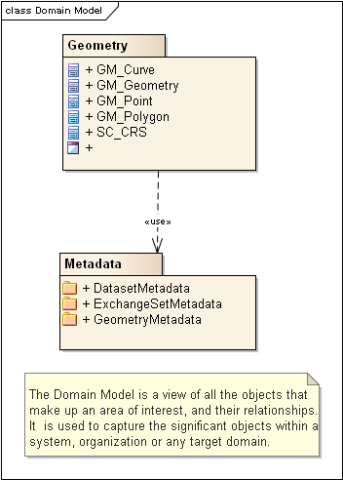

Figure 1 - Domain Model Overview

## Application Schema

The UML model shown in Figure 1 below illustrates a simplified version of the MPA application schema. It includes a general description of elements used to construct the application schema, and the relationships between them. These elements include features types, information types, simple attributes, complex attributes, aggregations and associations. A brief description of these is provided below and the full description is included in the feature catalogue.

A feature is an abstraction of real world phenomena. The GF_FeatureType meta-class is instantiated as classes that represent individual feature types.

A certain feature type is the class used to describe all instances of that kind of real world object, e.g. all chimneys irrespective of characteristics (e.g. colour), are encoded as Landmark feature type. In object-oriented modelling, feature types are equivalent to classes and feature instances are equivalent to objects.

An information type is an identifiable object that can be associated with features in order to carry information pertaining to the associated features. S100_GF_InformationType is the class intended for information types within S-100. A primary object carrying a Chart Note for example, may contain text in English and an associated supplementary information object may be used to carry the same text in another language.

Simple attributes can be enumerations, codelists or simple types (e.g. integer or character string).

Complex attributes are properties of a feature which can be divided into multiple sub attributes and are used where objects have properties that better fit a hierarchical structure. They provide a better construct for encoding list attributes on objects such as light sectors.

An association is a relationship that links instances of one feature or information type with instances of the same or different feature and information types. Each relationship has a name and two roles thus giving a more detailed representation of the real world relationships within the dataset. The MPA application schema is presented as UML model diagrams in Annex A.

## Feature Catalogue

### Introduction

The Feature Catalogue describes the feature types, information types, attributes, attribute values, associations and roles which may be used in the product. The S-122 Feature Catalogue is available in an XML document which conforms to the S-100 XML Feature Catalogue Schema and can be downloaded from the IHO website (include URL here). Simple attributes used in this specification are listed in Table 4.1 below.

## Feature Types

### Geographic

Include text here

### Meta

Meta features contain information about other features within a data set. Information defined by meta features override the default metadata values defined by the data set descriptive records. Meta attribution on individual features overrides attribution on meta features.

### Feature Relationship

A feature relationship links instances of one feature type with instances of the same or a different feature type.

### Information Types

Information types are identifiable pieces of information in a dataset that can be shared between other features. They have attributes but have no relationship to any geometry; information types may reference other information types.

### Attributes

S-122 defines attributes as either simple or complex.

#### Simple Attributes

S-112 uses four types of simple attributes; they are listed in the following table:

Table 4.1 – Simple feature attributes.

|  |  |
| --- | --- |
| **Type** | **Definition** |
| Enumeration | A fixed list of valid identifiers of named literal values |
| Boolean | A value representing binary logic. The value can be either True or False. The default state for Boolean type attributes (i.e. where the attribute is not populated for the feature) is False. |
| Real | A signed Real (floating point) number consisting of a mantissa and an exponent |
| Integer | A signed integer number. The representation of an integer is encapsulation and usage dependent. |
| CharacterString | An arbitrary-length sequence of characters including accents and special characters from a repertoire of one of the adopted character sets |
| Date | A date provides values for year, month and day according to the Gregorian Calendar. Character encoding of a date is a string which must follow the calendar date format (complete representation, basic format) for date specified by ISO 8601:1988.  EXAMPLE 19980918 (YYYY-MM-DD) |
| Time | A time is given by an hour, minute and second. Character encoding of a time is a string that follows the local time (complete representation, basic format) format defined in ISO 8601:1988.  EXAMPLE 183059 or 183059+0100 or 183059Z |
| Date and Time | A DateTime is a combination of a date and a time type. Character encoding of a DateTime shall follow ISO 8601:1988  EXAMPLE 19850412T101530 |

#### Complex Attributes

Complex attributes are aggregations of other attributes that are either simple or complex. The aggregation is defined by means of attribute bindings.

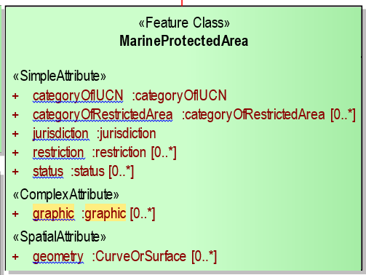

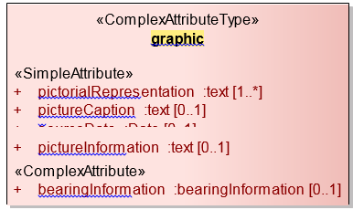

*EXAMPLE In this example the “graphic” complex attribute may have 0 or more simple attributes.*

## Dataset Loading and Unloading

< This section is only needed if the intended product specification has datasets that have multiple scales and would require a loading strategy>

## Geometric Representation

Geometric representation is the digital description of the spatial component of an object as described in S-100 and ISO 19107. This product specification uses three types of geometries: GM_Point, GM_Curve, and GM_Polygon (GM_Surface).

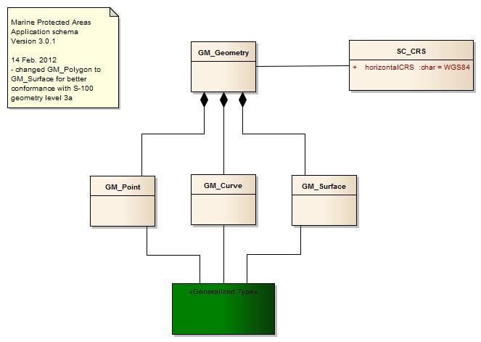

Figure 3 - Geometric Primitives

## Coordinate Reference System (CRS)

### Introduction

The location of an object in the S-100 standard is defined by means of coordinates which relate a feature to a position. The coordinate reference system used for this product specification is World Geodetic System 1984 (WGS 84) which is defined by the European Petroleum Survey Group (EPSG) code 4326, (or similar - North American Datum 1983 / Canadian Spatial Reference System).

Spatial data are expressed as latitude (φ) and longitude (λ) geographic coordinates. Latitude values are stored as a negative number to represent a position south of the Equator. Longitude values are stored as a negative number to represent a position west of the Prime Meridian. Coordinates are expressed as real value, degree / degree decimal format. Datasets conforming to this product specification are not projected.

**Horizontal coordinate reference system:** WGS 84

**Projection:** None

**Vertical coordinate reference system:** Although all coordinates in a data set must refer to the same horizontal CRS different Vertical Datums can be used for the depth component of a coordinate tuple. Therefore the vertical CRS can be repeated. For each Vertical CRS a unique identifier is defined. Those identifiers will be used to indicate which Vertical CRS is used. Units must be in meters. (From S-101 Draft).

**Temporal reference system:** Gregorian calendar

**Coordinate reference system registry:** [EPSG Geodetic Parameter Registry](http://www.epsg-registry.org/)

**Date type (according to ISO 19115):** 002 - publication

### Horizontal reference system

Positional data is expressed in latitude and longitude geographic coordinates to one of the reference horizontal reference systems defined in the HORDAT attribute. Unless otherwise defined, the World Geodetic System 84 (WGS 84) will be used for MPA data products.

### Projection

MPA data products are un-projected.

### Vertical coordinate reference system

Although all coordinates in a data set must refer to the same horizontal CRS different Vertical Datums can be used for the depth component of a coordinate tuple. Therefore the vertical CRS can be repeated. For each Vertical CRS a unique identifier is defined. Those identifiers will be used to indicate which Vertical CRS is used. Units must be in meters.

### Temporal reference system

Time is measured by reference to Calendar dates and Clock time in accordance with ISO 19108:2002 Temporal Schema clause 5.4.4.

# Data Quality

## Introduction

< The data quality overview element should include at least the intended purpose and statement of quality or lineage. Other data quality elements cover: completeness, logical consistency, positional accuracy, temporal accuracy, thematic accuracy, and anything specifically required for the product being specified.>

## Completeness

A Marine Protected Areas data set is complete when …. and mandatory associated metadata is provided.

## Test Case for MPA Geometry

Test purpose: Verify that geometry corresponds to one of two conformance classes:

- Conformance class 1 – vector coverage;

Test method: Check that the vector geometry types comply with one of the types defined in the Application Schema defined in Appendix A.

Test type: Basic.

## Test Case for extra data

Test purpose: Verify that an MPA data set is complete by testing that …. and all of the mandatory associated metadata is provided.

Test method: Check that for each feature ….. all of the mandatory metadata is provided and that all of the ….

Test type: Basic.

## Test Case for empty data

Test purpose: Verify that data is not missing.

Test method: Check that all mandatory metadata is provided for all feature instances.

Test type: Basic.

## Logical Consistency

Test purpose: Verify that data is not missing.

Test method: Check that all ….

Test type: Basic.

## Conceptual Consistency

The implementation of the MPA specification is required to align with one of the two conformance classes defined in (the Appendix ? with the Abstract Test Suite and Conformance Classes).

## Domain Consistency

The attributive values are validated to ensure they are within defined range.

## Test Case

Test purpose: Verify that attribute values are within ….

Test method: Check that the ….

Test type: Basic.

## Format Consistency

The structure of this product specification is independent from the data format. The data format encoding may be in accordance with different encoding specification. Conformance rules for each particular encoding are different and dependent on the particular encoding.

## Test Case

Test purpose: Verify that the format is compliant with the formats allowed for encoding vector data.

Test method: The format consistency test is done by encoding test software.

Test type: Basic.

## Positional Accuracy

For vector the positional accuracy ….

## Test Case

Test purpose: Verify that the … defined and in accordance with the accuracy established for the data set by the producer, official national authority.

Test method: Verify that the positional accuracy of the defining points of the product are within the accuracy established for the data set by the producer, in particular the Hydrographic Office, by the use of test software.

Test type: Basic.

## Temporal Accuracy

For a vector datasets the temporal reference time for the data ….

## Thematic Accuracy

### Thematic Classification Correctness

To be developed ….

## Non Quantitative Attribute Accuracy

The method used for evaluating the accuracy of the non-quantitative attribute values may be expressed in the metadata.

## Quantitative Attribute Accuracy

The method used for evaluating the accuracy of the quantitative attribute values with respect to reality is determined by the method of acquisition, and may be expressed in the metadata.

<S-100 Part 11-8>

The data product specification shall identify the data quality requirements for each scope within the data product in accordance with S-100 Part 3. For every data quality scope it is necessary to list all the data quality elements and data quality sub-elements defined in S-100 Part 3, even if only to state that a specific data quality element or data quality sub-element is not applicable for this data quality scope.

Each product specification shall describe the data quality requirements. One aspect is the “data quality overview element” which should allow a user to decide whether this dataset is the one they want. The other aspect is the metadata allowed for specific feature collections, features and attributes within the dataset.

The data quality overview element should include at least the intended purpose and statement of quality or lineage. Other data quality elements cover: completeness, logical consistency, positional accuracy, temporal accuracy, thematic accuracy, and anything

specifically required for the product being specified.

The product specification should comment on which of these are to be used and how, including a description of (or reference to) conformance tests. For example, should data only be published if it passes a particular test, or is it allowable to publish the data with a quality statement which indicates non-conformance? The product specification shall describe how each quality element is to be populated, for example, stating the mechanism to reference the quality evaluation procedure, and allowable values for the quality results.

The application schema shall indicate how the data quality elements will be related to the data items, for example whether a particular dataset should have homogeneous quality, or whether quality elements can be related to feature collections, individual feature objects or attributes.

Finally, the encoding description (clause 15) shall indicate how the quality elements will be encoded.

# Data Capture and Classification

<The data product specification shall provide information on how the data is to be captured. This should be as detailed and specific as necessary.>

S-122 products must be based on data sources released by an appropriate MPA defining authority. Data source must be described in each data product.

The production process used to generate MPA products may be described in the dataset metadata.

**Table 6.0 — Data capture information**

|  |  |  |  |
| --- | --- | --- | --- |
| **Item Name** | **Description** | **Multiplicity** | **Type** |
| dataSource | Identification of the kinds of data sources  usable to product datasets compliant with the  considering specification | 0..* | CharacterString |
| productionProcess | Link to a textual description of the production  process (including encoding guide)  applicable to the datasets compliant with the  considering specification | 0..* | CharacterString (URL) |

## Data Encoding and Product Delivery

### Data Encoding

The principal encoding will be the Open Geospatial Consortium (OGC), Geography Markup Language (GML) format. GML is an XML grammar designed to express geographical features. It serves as a modelling language for geographic systems as well as an open interchange format for geographic transactions.

*Note: ENC data cells are delivered in either the ISO 8211 format, or a proprietary internal System ENC (SENC) format. These are binary formats that are machine readable, but are not human readable. Although this product specification, specifies GML as the primary encoding format, it does not preclude the use of other encoding formats.*

### Data Product Delivery Information

This data product specification defines GML as the primary format in which MPA data products are delivered. The delivery format information should include the following items (from ISO 19131:2005 with some changes of obligation): format name, version, specification, language, character set. File structure and units of delivery can also be included if required.

Table 6.1.2 – Data Product Delivery

|  |  |  |
| --- | --- | --- |
| **Name** | **ISO 19131 Elements** | **Value** |
| Format name | DPS_DeliveryInformation.deliveryFormat > DPS_DeliveryFormat.formatName | GML* |
| Version | DPS_DeliveryInformation.deliveryFormat > DPS_DeliveryFormat.version | 3.2.1 |
| Specification description | DPS_DeliveryInformation.deliveryFormat > DPS_DeliveryFormat.specification | GML* |
| Language | DPS_DeliveryInformation.deliveryFormat > DPS_DeliveryFormat.language | English English |
| Character set | DPS_DeliveryInformation.deliveryFormat > DPS_DeliveryFormat.characterSet > MD_CharacterSetCode | 004 – utf8 |

Table x -

*\* GML is an XML encoding for the transport and storage of geographic information, including both the geometry and the properties of geographic features, between distributed systems. The XML Schema for the GML application schema is provided in a single schema document MPA.xsd. (http://www.iho.int/schemas/MPA …). Feature instance shall validate against MPA.xsd and conform to all other requirements specified in this data product specification including all constraints not captured in the XML Schema document.*

### Exchange Set

An exchange set will consist of one or more MPA datasets. An exchange set may also include one or more support files containing supplementary information encoded in separate files. These are linked to the MPA dataset features, using the attributes described below. Each exchange set will include a single (XML) catalogue file [content and format to be defined – based on S-101 work] containing discovery metadata for each MPA dataset as well as support files.

### Support Files

Support files contain ancillary textual or graphic information in separate (linked) files. Information should be encoded in a structured format as defined by W3C. The following formats would be suitable for graphics:

* Portable Network Graphics (PNG) [Edition 2.0]
* Scalable Vector Graphics (SVG) [Edition 1.1]
* Tagged Image File Format (TIFF) [Edition 6.0]
* Joint Photographic Experts Group (JPEG) [Edition 1.02 ]

*Note: PNG is an extensible file format designed for lossless, portable storage of raster images. It provides a patent-free replacement for the GIF format and also replicates many common uses of TIFF. The PNG edition 2 format has been adopted as an ISO standard, (ISO/IEC 15948:2003). SVG is a language for describing two-dimensional graphics in XML [XML10]. SVG allows for three types of graphic objects: vector graphic shapes (e.g., paths consisting of straight lines and curves), images and text. The JPEG standard specifies the codec, which defines how an image is compressed into a stream of bytes and decompressed back into an image, but not the file format used to contain that stream. (The term "JPEG" is an acronym for the Joint Photographic Experts Group, which is the body that created the standard).*

### Support File Naming Convention

All support files will have unique world-wide file identifiers. The file identifier of support information should not be used to describe the physical content of the file. The support file metadata that accompanies the file will inform the user of the name and purpose of the file (new, replacement and deletion).

In this encoding the support files are named according to the specifications given below:

CCNPIMPAXXXXXXXX.YYY

The main part forms an identifier where:

* the first two characters identify the issuing agency
* the third to fifth characters must be NPI to identify that this is nautical publication information,
* the sixth to eighth characters must be MPA to identify that this is Maritime Protected Area information,
* the ninth up to the sixteenth character can be used in any way by the producer to provide a unique file name for the dataset. The following characters are allowed in the dataset name, A to Z, 0 to 9 and the special character _ (underscore).
* .YYY – support file extension.

### Dataset Naming Convention

All dataset files will have unique world-wide file identifiers. The file identifier of the dataset should not be used to describe the physical content of the file. The dataset file metadata that accompanies the file will inform the user of the name and purpose of the file (new, replacement and deletion).

In this encoding the dataset files are named according to the specifications given below:

CCNPIMPAXXXXXXXX.GML

The main part forms an identifier where:

* the first two characters identify the issuing agency
* the third to fifth characters must be NPI to identify that this is nautical publication information,
* the sixth to eighth characters must be MPA to identify that this is Maritime Protected Area information,
* the ninth up to the sixteenth character can be used in any way by the producer to provide a unique file name for the dataset. The following characters are allowed in the dataset name, A to Z, 0 to 9 and the special character _ (underscore).

### Catalogue File Naming Convention

The exchange catalogue acts as the table of contents for the exchange set. The catalogue file of the exchange set must be named CATALOG.10X. No other file in the exchange set may be named CATALOG.10X. The content of the exchange catalogue file is described in Section 16.2.1.

### Dataset Maintenance

Datasets are maintained as needed and must include mechanisms for MPA updating. Data updates will be made by new editions. (This is the current view of SNPWG 14. It may be necessary to introduce incremental updates at a later stage.)

Data Producers must use applicable sources to maintain and update data and provide a brief description of the sources that were used to produce the dataset in the appropriate metadata field.

The maintenance and update frequency of MPA data sets should be defined by the producers (official national authority) implementing this specification.

The data product shall provide information on how the data is maintained and should describe the principles and criteria applied in maintenance regime. This should specify the expected frequency of updates.

Table 6.1.8 - Maintenance and Update Frequency

|  |  |  |  |
| --- | --- | --- | --- |
| **Item Name** | **Description** | **Multiplicity** | **Type** |
| maintenanceAndUpdateFrequency | Frequency with which changes and additions are made to the data product (per update scope) | 1..* | MD_MaintenanceInformation (ISO 19115) |
| dataSource | Identification of the kinds of data sources usable to produce datasets | 1..* | LI_Source (ISO 19115) |
| productionProcess | Textual description of the production process applicable to the datasets (per scope or data source) | 1..* | LI_ProcessStep (ISO 19115) |

# Portrayal

See attribute category of restricted area CATREA enumerations: (i.e. offshore safety zone, nature reserve, bird sanctuary, game reserve, seal sanctuary ….)

Include the portrayal section when completed.

The Portrayal Catalogue contains portrayal functions that map features to symbology. It also contains symbol definitions, colour definitions, portrayal parameters and portrayal management concepts such as viewing groups. Each catalogue should include a reference to a portrayal library that contains a set of portrayal rules and a set of portrayal specifications (Table 9.1). This information should be included in the product specification for each identified scope.

Table 7.0 - Portrayal Information

|  |  |  |  |  |
| --- | --- | --- | --- | --- |
| **Item Name** | **Description** | **M/O** | **Card** | **Type** |
| portrayalLibraryCitation | Bibliographic reference to the portrayal library | O | 0..1 | CI_Citation (ISO 19115) |

# Metadata

## Introduction

The MPA metadata description is based on the S-100 metadata document section, which is a profile of the ISO 19115 standard. These documents provide a structure for describing digital geographic data and define metadata elements, a common set of metadata terminology, definitions and extension procedures.

Two metadata packages are described in this product specification: dataset metadata and exchange set metadata.

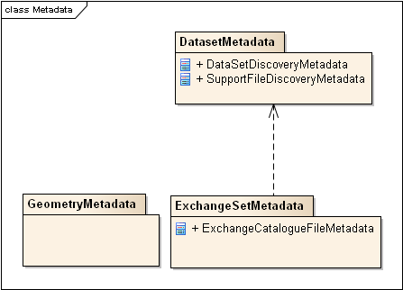

## Dataset Metadata

Dataset metadata is intended to describe information about a dataset or data resource. It facilitates the management and exploitation of data and is an important requirement for understanding the characteristics of a dataset (and / or data resource). Whereas dataset metadata is usually fairly comprehensive, there is also a requirement for a constrained subset of metadata elements that are usually required for discovery purposes. Discovery metadata are often used for building web catalogues, and can help users determine whether a product or service is fit for purpose and where they can be obtained. Information about the documented metadata (if provided as a separate resource)

Table 8.2 – Dataset Metadata

|  |  |  |  |  |
| --- | --- | --- | --- | --- |
| **Name** | **Cardinality** | **Value** | **Type** | **Remarks** |
| DataSetDiscoveryMetadata |  |  |  |  |
| metadataFileIdentifier | 1 |  | CharacterString | See section 15 |
| metadataPointOfContact | 1 |  | CI_ResponsibleParty | Contact information for the data production authority |
| metadataDateStamp | 1 |  | Date | When the dataset was created |
| metadataLanguage | 1..2 | English or French | CharacterString | All data sets conforming to this PS must use English and optionally French |
| fileName | 1 |  | CharacterString | Dataset file name |
| filePath | 1 |  | CharacterString | Full path from the exchange set root directory |
| description | 1 |  | CharacterString |  |
| dataProtection | 1 | {1} or {2} | CharacterString | 1. Encrypted  2. Unencrypted |
| purpose | 1 | {1} or {2} | CharacterString | 1. New dataset  2. Terminated |
|  |  |  |  |  |
|  |  |  |  |  |
|  |  |  |  |  |
| specificUsage | 0..1 |  | CharacterString | brief description of the resource and/or resource series usage |
|  |  |  |  |  |
| editionNumber | 1 | {1} | Integer | When a dataset is initially created, the edition number “1” is assigned to it. The edition number is increased by one with each new edition. |
| issueDate | 1 |  | Date | Date on which the dataset was generated. |
| productSpecification | 1 | MPA version XXX | CharacterString | This must be encoded as MPA XXX |
| producingAgency | 1 |  | CI_ResponsibleParty | Party responsible for generating the dataset. |
| horizontalDatum | 1 | WGS84 | CharacterString | The datum for latitude/longitude. EPSG:4326 |
| verticalDatum | 1 | WGS84 | CharacterString | EPSG:4326 |
|  |  |  |  |  |
| dataType | 1 | GML 3.2.1 | CharacterString |  |
| boundingBox | 0..1 |  | EX_GeographicBoundingBox | minimum bounding rectangle within which data is available |
| boundingPolygon | 1..* |  | EX_BoundingPolygon | boundary enclosing the dataset, expressed as the closed set of (x,y) coordinates of the polygon (last point replicates first point) |
| geographicDescription | 0..1 | e.g. Norway | EX_GeographicDescription | description of the geographic area within which data is available |
| comment | 0..1 |  | CharacterString | Any additional Information |

Table 2

*Note 1: Types with CI_, EX_, and MD_ prefixes are from packages defined in ISO 19115 and adapted by S-100. Types with S100_ prefix are from packages defined in S-100.*

*Note 2: When a dataset is terminated, the purpose metadata field is set to 2 (terminated), and the editionNumber metadata field is set to 0. All other metadata fields must be blank.*

*Note 3: The implication of only updating by new edition is that, if a support file is terminated, a new edition of the dataset is required.*

## Exchange Set Metadata

Frequently datasets are packaged and distributed as composite exchange sets by third party vendors. An exchange set could contain many different types of datasets, sourced from different data producers. For example an exchange set may contain numerous dataset files, ancillary data files, discovery metadata files and others. Exchange set metadata contains metadata about the contents of the exchange set and metadata about the data distributor.

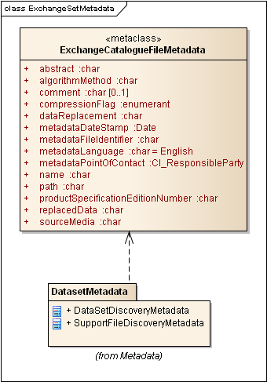

Figure 5 Exchange Set Metadata

## Catalogue File Metadata.

All MPA Catalogue metadata files must contain at least the following metadata elements.

Table 8.4 Catalogue File Metadata

|  |  |  |  |  |  |
| --- | --- | --- | --- | --- | --- |
| **Name** | **Cardinality** | | **Value** | **Type** | **Remarks** |
| abstract | 0..1 |  | | CharacterString | Description of what the exchange catalogue contains |
| AlgorithmMethod | 0 ..1 | e.g. ZIP Compression | | CharacterString | algorithms or processes that are applied to read or expand resources to which compression techniques have been applied |
| metadataFileIdentifier | 1 |  | | CharacterString | See section 15 |
| metadataPointOfContact | 1 |  | | CI_ResponsibleParty | Contact information for the data production authority |
| metadataDateStamp | 1 |  | | Date | Date when the dataset was created |
| metadataLanguage | 1..2 | English, French | | CharacterString | All data sets conforming to this PS must use English language. The catalogue file must be in English with the optional addition of French. |
| name | 1 | CATALOG.MPA | | CharacterString | Catalogue filename |
| path | 1 | URI | | CharacterString | Path to filename |
| productSpecification | 1 | S-122 | | CharacterString | Product specification Version Number |
| comment | 0..1 |  | | CharacterString | Any additional Information |



**Application Schema**

The Applications Schema diagrams are included below (see sections …).

**MPA Feature Types**

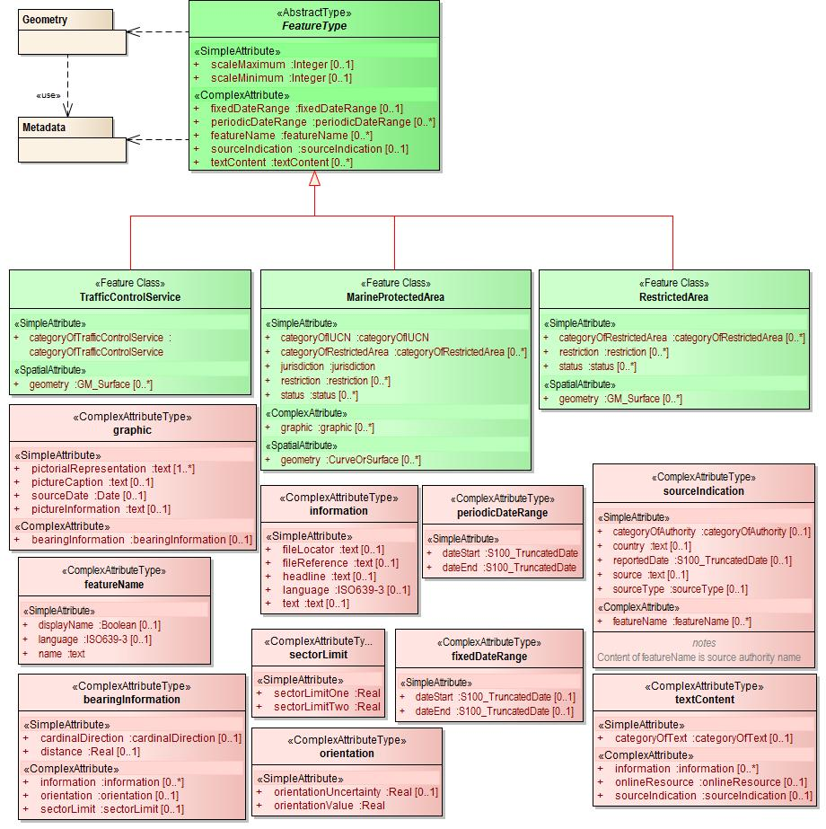

Figure A-1

**MPA Information Types**

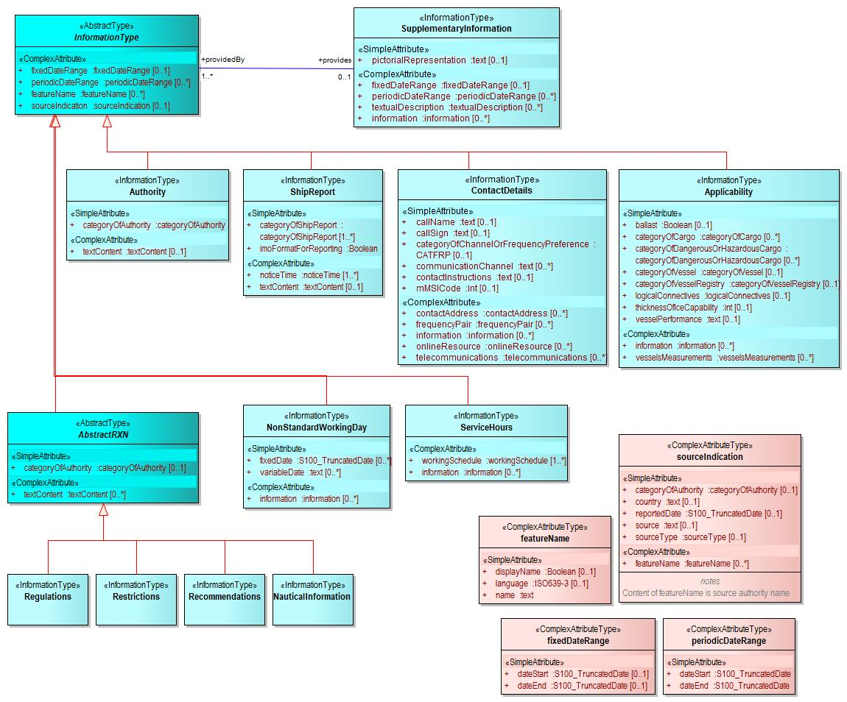

Figure A-2

**Information Area and Supplementary Information**

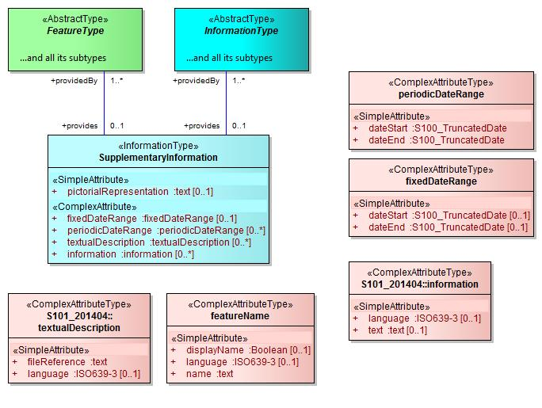

Figure A-3

**Regulations, Restrictions, Recommendations, and Nautical Information**.

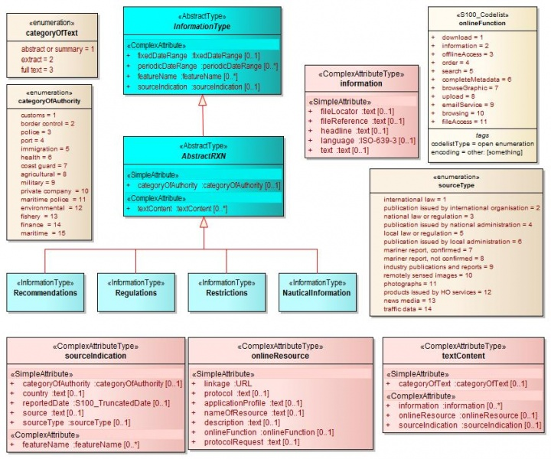

Figure A-4

**Authorities and Contact Information**

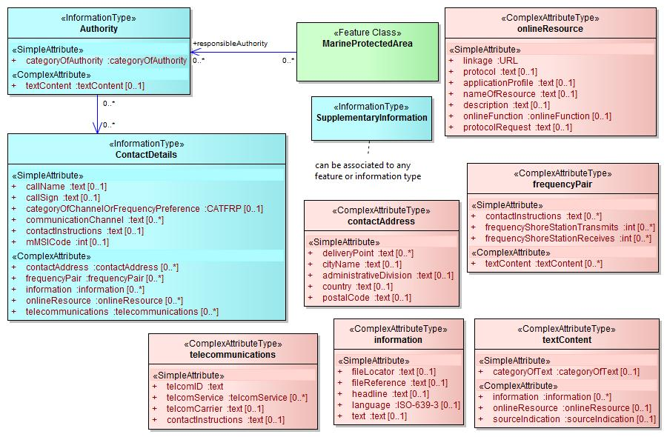

**Figure A-5**

**Business hours for authorities.**

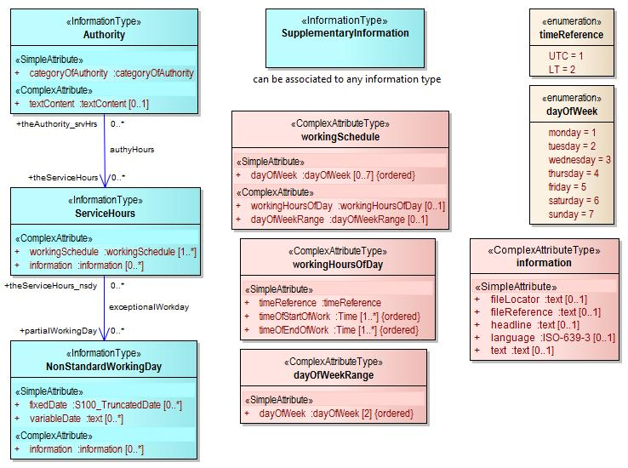

**Figure A-6**

**Reporting.**

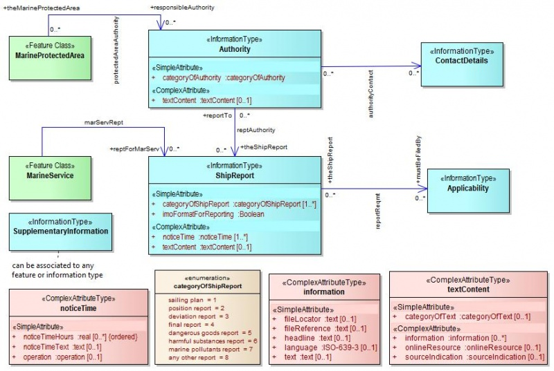

**Figure A-7**

**Defining vessel categories by cargo and ship dimensions.**

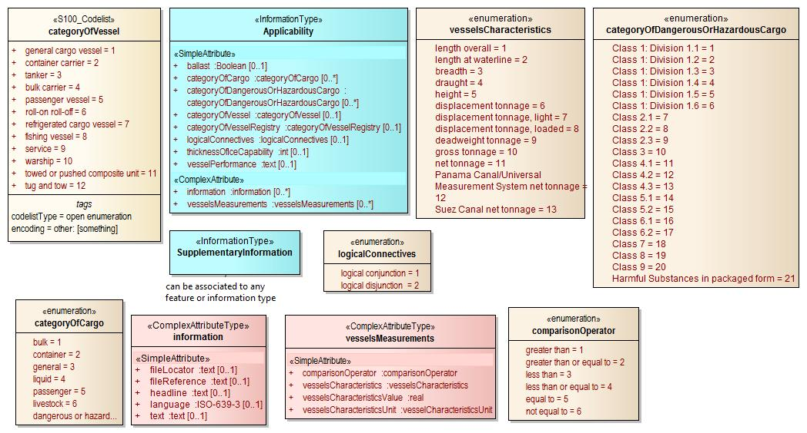

**Figure A-8**

**Applicability of reporting requirements, rules, etc. to vessel categories**

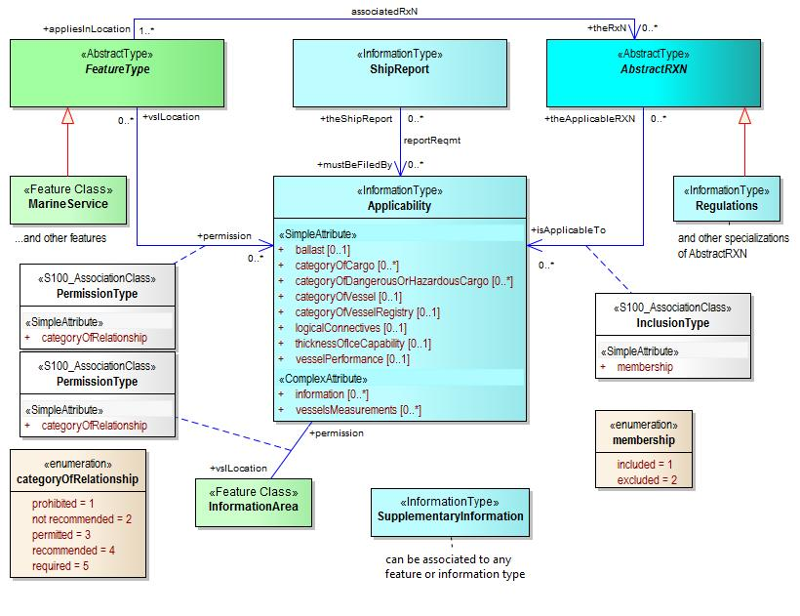

**Figure A-9**

**Regulations, etc., with Unconstrained Applicability.**

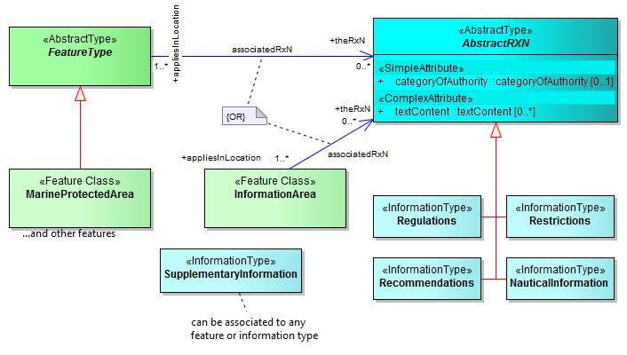

**Figure A-10**

**Information type Contact Details and its attributes**

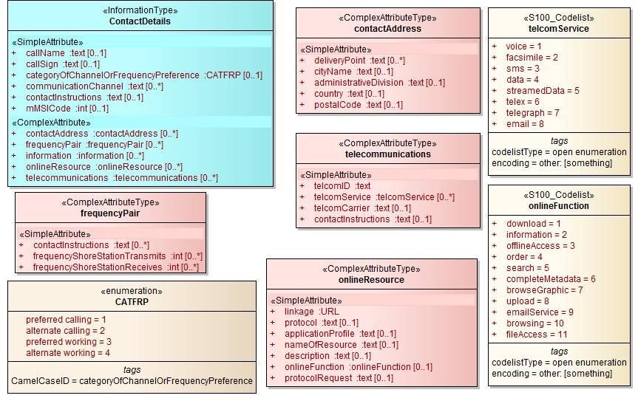

**Figure A-11**

**Context features overview**

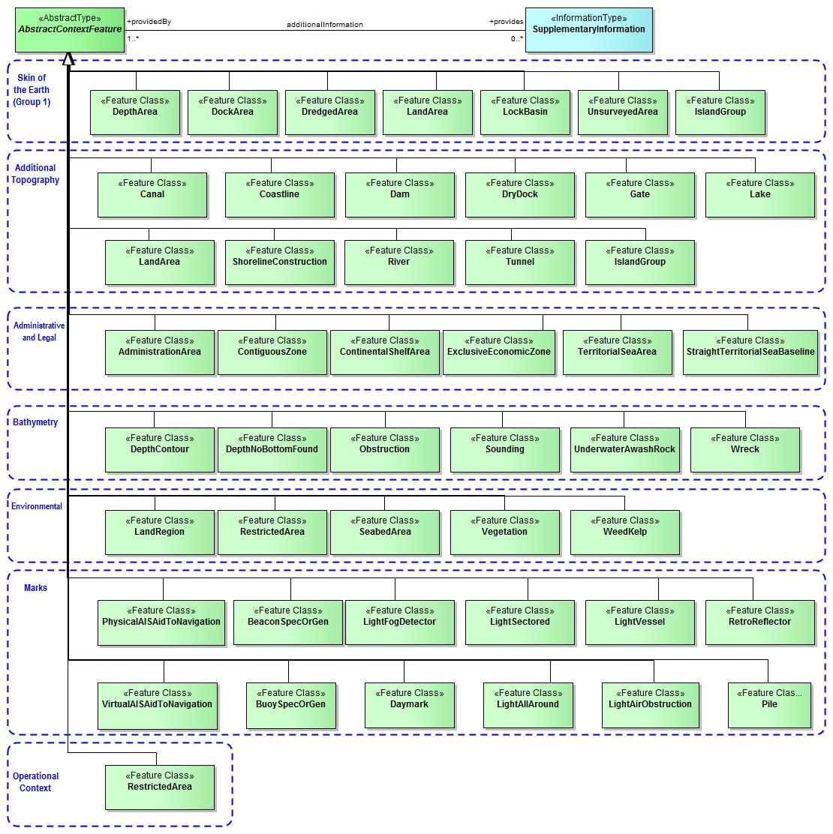

**Figure A-11**



**Feature Catalogue**

**Name:** Marine Protected Areas Feature Catalogue

**Scope:**

**Version Number:** 1.n

**Version Date:** 2015-mm-dd

**Producer:**

International Hydrographic Bureau,   
4 quai Antoine 1er,

B.P. 445

MC 98011 MONACO CEDEX

Telephone: +377 93 10 81 00

Telefax: + 377 93 10 81 40

See clause 5.6

**Language:** English

**Feature Types (Classes)**

**Geo Object Class: Marine Protected Area**

Alpha code: **MPAREA**

Camel case: **MarineProtectedArea** Abstract type: False

Definition: An area where restrictions apply to protect the environment. References: INT 1 (still to be defined)

Remarks: No remarks. Spatial Objects: Point (GM_Point); Area (GM_Polygon)   
Distinction: None.

|  |  |  |  |  |
| --- | --- | --- | --- | --- |
| ***Attribute*** | ***Camel Case Name*** | ***Alpha Code*** | ***Cardinality*** | ***Sequential*** |
| *C Information* | *cInformation* | *CINFOM* | *0..\** |  |
| *C object name* | *cObjectName* | *COBNAM* | *1..\** |  |
| *C Text Description* | *cTextualDescription* | *CTXDSC* | *1..\** |  |
| *Category of restricted area* | *categoryOfRestrictedArea* | *CATRES* | *1..\** |  |
| *Category of IUCN* | *categoryOfIUCN* | *CIUCNO* | *0..1* |  |
| *Source indication* | *sourceIndication* | *SORIND* | *0..\** |  |
| *Period start* | *periodStart* | *PERSTA* | *0..1* |  |
| *Period end* | *periodEnd* | *PEREND* | *0..1* |  |
| *Date start* | *dateStart* | *DATSTA* | *0..1* |  |
| *Date end* | *dateEnd* | *DATEND* | *0..1* |  |
| *Source date* | *sourceDate* | *SORDAT* | *0..\** |  |
| *Jurisdiction* | *jurisdiction* | *JRSDTN* | *0..1* |  |
| *Status* | *status* | *STATUS* | *0..\** |  |
| *Scale minimum* | *scaleMinimum* | *SCAMAX* | *0..1* |  |
| *Scale maximum* | *scaleMaximum* | *SCAMIN* | *0..1* |  |
| *Restriction* | *restriction* | *RESTRN* | *1..\** |  |
| *Pictorial Representation* | *pictorialRepresentation* | *PICREP* | *0..\** |  |

**Information Types**

**Applicability**

Alpha code: **APPLIC**

Camel Case: **Applicability** Abstract type: False

Definition: Describes the relationship between vessel characteristics and: (i) the applicability of an associated information object or feature to the vessel; or, (ii) the use of a facility, place, or service by the vessel; or, (iii) passage of the vessel through an area.

References: Unspecified.

Remarks: No remarks.

Distinction: None

|  |  |  |  |  |
| --- | --- | --- | --- | --- |
| ***Attribute*** | ***Camel Case Name*** | ***Alpha Code*** | ***Cardinality*** | ***Sequential*** |
| *Start date* | *dateStart* | *DATSTA* | *0..1* |  |
| *End date* | *dateEnd* | *DATEND* | *0..1* |  |
| *Period start* | *periodDateEnd* | *PEREND* | *0..1* |  |
| *Period end* | *periodStart* | *PERSTA* | *0..1* |  |
| *Recording date* | *recordingDate* | *RECDAT* | *0..1* |  |
| *Recording Indication* | *recordingIndication* | *RECIND* | *0..1* |  |
| *Source date* | *sourceDate* | *SORDAT* | *0..1* |  |
| *Source indication* | *sourceIndication* | *SORIND* | *0..1* |  |
| *C Information* | *cInformation* | *CINFOM* | *0..\** |  |
| *C Text description* | *cTextualDescription* | *CTXDSC* | *0..\** |  |
| *C Object name* | *cObjectName* | *COBNAM* | *0..\** |  |
| *Category of vessel* | *categoryOfVessel* | *CATVES* | *0..1* |  |
| *Category of cargo* | *categoryOfCargo* | *CATCAR* | *0..1* |  |
| *Category of dangerous or hazardous cargo* | *categoryOfDangerousOrHazardousCargo* | *CATDCO* | *0..1* |  |
| *Category of relationship* | *categoryOfRelationship* | *CATREL* | *0..1* |  |
| *category of vessel registry* | *categoryOfVesselRegistry* | *CATVSR* | *0..1* |  |
| *Logical Connectives* | *logicalConnectives* | *LOGCON* | *0..1* |  |
| *Thickness of ice Capability* | *thicknessOfIceCapability* | *ICETHK* | *0..1* |  |
| *Vessel performance* | *vesselPerformance* | *VESPER* | *0..1* |  |
| *Vessels measurements* | *vesselsMeasurements* | *VESMSR* | *0..\** |  |

*Relationships*

| ***Multiplicity*** | ***Association*** |
| --- | --- |
| ***0..\****  ***0..\**** | *Regulations .*  *Applicability .Applicability* |
| ***0..*  0..\**** | *Restrictions .*  *Applicability .Applicability* |
| ***0..\**** | *vesselsMeasurements .*  *Applicability .* |
| ***0..\**** ***0..\**** | *NauticalInformation  Applicability .Applicability* |  |
| ***0..\****  ***0..\**** | *ShipReport.managementAuthority*  *Applicability .Applicability* |  |
| ***0..*  0..\**** | *Recommendations .*  *Applicability .Applicability* |  |
|  | *Applicability .*  *InformationType.* |  |
| **0..1** | underKeelClearance .  Applicability . |  |

**Authority**

Alpha code: AUTORI

Camel Case: **Authority** Abstract type: False  
  
Definition: A person or organisation having political or administrative power and control. (Oxford Dictionary of English)  
  
References: Unspecified.  
   
Remarks: No remarks.  
   
Distinctions: natinf; rcmdts; resdes;

|  |  |  |  |  |
| --- | --- | --- | --- | --- |
| **Attribute** | **Camel Case Name** | **Alpha Code** | **Cardinality** | **Sequential** |
| Start date | sourceIndication | SORIND | 0..* |  |
| End date | categoryOfAuthority | CATAUT | 0..1 |  |
| Period start | periodStart | PERSTA | 0..1 |  |
| Source date | sourceDate | SORDAT | 0..* |  |
| Recording date | dateStart | DATSTA | 0..1 |  |
| Recording Indication | periodDateEnd | PEREND | 0..1 |  |
| Source date | dateEnd | SATEND | 0..1 |  |
| Source indication | recordingDate | RECDAT | 0..1 |  |
|  | recordingIndication | RECIND | 0..1 |  |
| C Information | cInformation | CINFO | 0..* |  |
| C Text description | cTextualDescription | CTXDSC | 0..* |  |
| C Object name | cObjectName | COBNAM | 0..* |  |

Relationships

| **Multiplicity** | **Association** |
| --- | --- |
| **0..\***  **0..\*** | Authority.managementAuthority  ServiceHours .ServiceHours |
| **0..\***  **0..\*** | Authority.issuingAuthority  ShipReport.shipReport |
| **0..\***  **0..\*** | Authority.managementAuthority ContactDetails .ContactDetails |
| **0..\***  **0..\*** | MarineProtectedArea .  Authority.Authority |
|  | Authority.  InformationType. |

**Contact Details**

Alpha code: CONDET

Camel Case: **ContactDetails** Abstract type: False

Definition: Information on how to reach a person or organisation by postal, internet, telephone, telex and radio systems.

References: Unspecified.

Remarks: None.

Distinctions: None

|  |  |  |  |  |
| --- | --- | --- | --- | --- |
| **Attribute** | **Camel Case Name** | **Alpha Code** | **Cardinality** | **Sequential** |
| source Indication | sourceIndication |  | 0..* |  |
| source Date | sourceDate |  | 0..* |  |
| period Start | periodStart |  | 0..1 |  |
| periodDateEnd | periodDateEnd |  | 0..1 |  |
| dateEnd | dateEnd |  | 1,0 |  |
| dateStart | dateStart |  | 0..1 |  |
| callSign | callSign |  | 1 |  |
| callName | callName |  | 0..1 |  |
| adminstrativeDivision | adminstrativeDivision |  | 0..1 |  |
| cInformation | cInformation |  | 0..* |  |
| cTextualDescription | cTextualDescription |  | 0..* |  |
| cObjectName | cObjectName |  | 0..* |  |
| internetAddress | internetAddress |  | 0..1 |  |
| cityName | cityName |  | 0..1 |  |
| communicationChannel | communicationChannel |  | 0..1 |  |
| country | country |  | 0..1 |  |
| recordingDate | recordingDate |  | 0..1 |  |
| recordingIndication | recordingIndication |  | 0..1 |  |
| deliveryPoint | deliveryPoint |  | 0..1 |  |
| maritimeMobileServiceIdentityCode | maritimeMobileServiceIdentityCode |  | 0..1 |  |
| telephoneNumber | telephoneNumber |  | 1 |  |
| emailAddress | emailAddress |  | 1 |  |
| telephoneNumberOutsideWorkingHours | telephoneNumberOutsideWorkingHours |  | 1 |  |
| faxNumber | faxNumber |  | 1 |  |
| postalCode | postalCode |  | 1 |  |

Relationship

| **Multiplicity** | **Association** |
| --- | --- |
| **0..\***  **0..\*** | Authority.managementAuthority  ContactDetails .ContactDetails |
|  | ContactDetails  InformationType. |

**Nautical Information**

Alpha code: **NATINF**

Camel Case: **NauticalInformation** Abstract type: False

Definition: Nautical information about a related area or facility.  
  
References: INT 1: M-3: Chapter C 2.2.1, C 2.7, C 2.8, Chater 3 Section C, Chapter 3 Section E, M-4:  
  
Remarks: None.  
   
Distinctions: None

|  |  |  |  |  |
| --- | --- | --- | --- | --- |
| **Attribute** | **Camel Case Name** | **Alpha Code** | **Cardinality** | **Sequential** |
| Category of  authority | categoryOfAuthority | CATAUT | 1 |  |
| Start date | dateStart | DATSTA | 0..1 |  |
| End date | dateEnd | DATEND | 0..1 |  |
| Period start | periodDateEnd | PEREND | 0..1 |  |
| Period end | periodStart | PERSTA | 0..1 |  |
| Recording date | recordingDate | RECDAT | 0..1 |  |
| Recording Indication | recordingIndication | RECIND | 0..1 |  |
| Source date | sourceDate | SORDAT | 0..1 |  |
| Source indication | sourceIndication | SORIND | 0..1 |  |
| C Information | cInformation | CINFOM | 0..* |  |
| C Text description | cTextualDescription | CTXDSC | 0..* |  |
| C Object name | cObjectName | COBNAM | 0..* |  |

Relationships

| **Multiplicity** | **Association** |
| --- | --- |
| **0..\***  **0..\*** | NauticalInformation .  Applicability .Applicability |
| **0..*  0..\*** | MarineProtectedArea .  NauticalInformation .Information |
|  | NauticalInformation . Information. |

**Non-standard Working Day**

Alpha code: **NWKDAY**

Camel Case: **NonStdWkgDay** Abstract type: False

Definition: Days when many services are not available. Often days of festivity or recreation when normal working hours are limited, esp. a national or religious festival, etc.  
  
References: INT 1: M-3: M-4:  
  
Remarks: None.  
   
Distinctions: None

|  |  |  |  |  |
| --- | --- | --- | --- | --- |
| **Attribute** | **Camel Case Name** | **Alpha Code** | **Cardinality** | **Sequential** |
| Fixed date | fixedDate | FIXDAT | 0..* |  |
| Variable date | variableDate | VARDAT | 0..* |  |
| Start date | dateStart | DATSTA | 0..1 |  |
| End date | dateEnd | DATEND | 0..1 |  |
| Period start | periodDateEnd | PEREND | 0..1 |  |
| Period end | periodStart | PERSTA | 0..1 |  |
| Recording date | recordingDate | RECDAT | 0..1 |  |
| Recording Indication | recordingIndication | RECIND | 0..1 |  |
| Source date | sourceDate | SORDAT | 0..1 |  |
| Source indication | sourceIndication | SORIND | 0..1 |  |
| C Information | cInformation | CINFOM | 0..* |  |
| C Text description | cTextualDescription | CTXDSC | 0..* |  |
| C Object name | cObjectName | COBNAM | 0..* |  |

Relationships

| **Multiplicity** | **Association** |
| --- | --- |
|  | NonStandardWorkingDay. InformationType. |
| **0..\***  **0..\*** | NonStandardWorkingDay.information  ServiceHours .informationFor |

**Recommendations**

Alpha code: **RCMDTS**

Camel Case: **Recommendations** Abstract type: False

Definition: Recommendations for a related area or facility

References: INT 1: M-3: Chapter C 2.2.1, C 2.7, C 2.8, C 3.19, C 3.21 M-4:

Remarks: None.

Distinctions: None

|  |  |  |  |  |
| --- | --- | --- | --- | --- |
| **Attribute** | **Camel Case Name** | **Alpha Code** | **Cardinality** | **Sequential** |
| Category of authority | categoryOfAuthority | CATAUT | 0..1 |  |
|  |  |  |  |  |
| Start date | dateStart | DATSTA | 0..1 |  |
| End date | dateEnd | DATEND | 0..1 |  |
| Period start | periodDateEnd | PEREND | 0..1 |  |
| Period end | periodStart | PERSTA | 0..1 |  |
| Recording date | recordingDate | RECDAT | 0..1 |  |
| Recording Indication | recordingIndication | RECIND | 0..1 |  |
| Source date | sourceDate | SORDAT | 0..1 |  |
| Source indication | sourceIndication | SORIND | 0..1 |  |
| C Information | cInformation | CINFOM | 0..* |  |
| C Text description | cTextualDescription | CTXDSC | 0..* |  |
| C Object name | cObjectName | COBNAM | 0..* |  |

Relationships

| **Multiplicity** | **Association** |
| --- | --- |
| **0..*  0..\*** | MarineProtectedArea .  Recommendations .Recommendations |
| **0..*  0..\*** | Recommendations .  Applicability .Applicability |
|  | Recommendations .  InformationType. |

**Regulations**

Alpha code**: REGLTS**

Camel Case: Regulations Abstract type: False

Definition: Regulations for a related area or facility.

References: INT 1: M-3: Chapter C 2.2.1, C 2.7, C 2.8, C 3.19, C 3.21 M-4:

Remarks: None.

Distinctions: None

|  |  |  |  |  |
| --- | --- | --- | --- | --- |
| **Attribute** | **Camel Case Name** | **Alpha Code** | **Cardinality** | **Sequential** |
| Category of authority | categoryOfAuthority | CATAUT | 0..1 |  |
|  |  |  |  |  |
| Start date | dateStart | DATSTA | 0..1 |  |
| End date | dateEnd | DATEND | 0..1 |  |
| Period start | periodDateEnd | PEREND | 0..1 |  |
| Period end | periodStart | PERSTA | 0..1 |  |
| Recording date | recordingDate | RECDAT | 0..1 |  |
| Recording Indication | recordingIndication | RECIND | 0..1 |  |
| Source date | sourceDate | SORDAT | 0..1 |  |
| Source indication | sourceIndication | SORIND | 0..1 |  |
| C Information | cInformation | CINFOM | 0..* |  |
| C Text description | cTextualDescription | CTXDSC | 0..* |  |
| C Object name | cObjectName | COBNAM | 0..* |  |

Relationships

| **Multiplicity** | **Association** |
| --- | --- |
| **0..*  0..\*** | Regulations .  Applicability .Applicability |
| **0..\*** .  **0..\*** | MarineProtectedArea .  Regulations .Regulations |
|  | Regulations .  InformationType. |

**A.2.8 Restrictions**

Alpha code: **RESDES**

Camel Case: **Restrictions** Abstract type: False

Definition: Restrictions for a related area or facility.

References: INT 1: M-3: Chapter C 2.2.1, C 2.7, C 2.8, C 3.19, C 3.21 M-4

Remarks: None.

Distinctions: None

|  |  |  |  |  |
| --- | --- | --- | --- | --- |
| **Attribute** | **Camel Case Name** | **Alpha Code** | **Cardinality** | **Sequential** |
| Category of authority | categoryOfAuthority | CATAUT | 0..1 |  |
|  |  |  |  |  |
| Start date | dateStart | DATSTA | 0..1 |  |
| End date | dateEnd | DATEND | 0..1 |  |
| Period start | periodDateEnd | PEREND | 0..1 |  |
| Period end | periodStart | PERSTA | 0..1 |  |
| Recording date | recordingDate | RECDAT | 0..1 |  |
| Recording Indication | recordingIndication | RECIND | 0..1 |  |
| Source date | sourceDate | SORDAT | 0..1 |  |
| Source indication | sourceIndication | SORIND | 0..1 |  |
| C Information | cInformation | CINFOM | 0..* |  |
| C Text description | cTextualDescription | CTXDSC | 0..* |  |
| C Object name | cObjectName | COBNAM | 0..* |  |

Relationships

| **Multiplicity** | **Association** |
| --- | --- |
| **0..\***  **0..\*** | Restrictions .  Applicability .Applicability |
| **0..\***.  **0..\*** | MarineProtectedArea .  Restrictions .Restrictions |
|  | Restrictions . InformationType. |

**A.2.9 Service hours**

Alpha code: **SRVHRS**

Camel Case: **ServiceHours** Abstract type: False

Definition: The time when a service is available and known exceptions

References:

Remarks: None.

Distinctions: None

|  |  |  |  |  |
| --- | --- | --- | --- | --- |
| **Attribute** | **Camel Case Name** | **Alpha Code** | **Cardinality** | **Sequential** |
| Working schedule | workingSchedule | WRKSCH | 1 |  |
| Notice time | noticeTime | NOTCTM | 1 |  |
|  |  |  |  |  |
| Start date | dateStart | DATSTA | 0..1 |  |
| End date | dateEnd | DATEND | 0..1 |  |
| Period start | periodDateEnd | PEREND | 0..1 |  |
| Period end | periodStart | PERSTA | 0..1 |  |
| Recording date | recordingDate | RECDAT | 0..1 |  |
| Recording Indication | recordingIndication | RECIND | 0..1 |  |
| Source date | sourceDate | SORDAT | 0..1 |  |
| Source indication | sourceIndication | SORIND | 0..1 |  |
| C Information | cInformation | CINFOM | 0..* |  |
| C Text description | cTextualDescription | CTXDSC | 0..* |  |
| C Object name | cObjectName | COBNAM | 0..* |  |

| **Multiplicity** | **Association** |
| --- | --- |
| **1..\*** | noticeTime .ServiceHours . |
| **0..\***  **0..\*** | Authority.managementAuthority  ServiceHours .ServiceHours |
| **1..\***. | workingSchedule.ServiceHours . |
| **0..\***  **0..\*** | NonStandardWorkingDay.information  ServiceHours .informationFor |
|  | ServiceHours .InformationType. |

**A.2.10 IMO Ship Report**

Alpha code: **SHPREP**Camel Case: **ImoShipReport** Abstract type: False   
Definition: This describes how a ship should report to a maritime authority, including when to report, what to report and whether the format conforms to the IMO standard.  
  
References: IMO Resolution A 851(20) adopted 27 November 1997.  
  
Remarks: TXTDSC and NTXTDS are used to describe non-standard ship reports. The Associated Information Object chalim indicates characteristics of vessels which use this report.  
Distinctions: None

|  |  |  |  |  |
| --- | --- | --- | --- | --- |
| **Attribute** | **Camel Case Name** | **Alpha Code** | **Cardinality** | **Sequential** |
| Category of ship report | categoryOfShipReport | CATREP | 1 |  |
| IMO format for reporting | imoFormatForReporting | IMOREP | 1 |  |
|  |  |  |  |  |
| Start date | dateStart | DATSTA | 0..1 |  |
| End date | dateEnd | DATEND | 0..1 |  |
| Period start | periodDateEnd | PEREND | 0..1 |  |
| Period end | periodStart | PERSTA | 0..1 |  |
| Recording date | recordingDate | RECDAT | 0..1 |  |
| Recording Indication | recordingIndication | RECIND | 0..1 |  |
| Source date | sourceDate | SORDAT | 0..1 |  |
| Source indication | sourceIndication | SORIND | 0..1 |  |
| C Information | cInformation | CINFOM | 0..* |  |
| C Text description | cTextualDescription | CTXDSC | 0..* |  |
| C Object name | cObjectName | COBNAM | 0..* |  |

Relationships

| **Multiplicity** | **Association** |
| --- | --- |
| **0..\***  **0..\*** | ShipReport.managementAuthority  Applicability .Applicability |
| **0..\***  **0..\*** | Authority.issuingAuthority  ShipReport.shipReport |
|  | ShipReport. InformationType. |

**Feature Attributes**

**Date end**

Alpha code: **DATEND**

Attribute type: Simple

Camel case: dateEnd Data Type: Date

Definition: The attribute “date end” indicates the latest date on which an object (e.g. a buoy) will be present.

Constraints:

CCYYMMDD, consisting of 4 digits for the calendar year (CCYY), 2 digits for the month (MM) (e.g. April = 04) and 2 digits for the day (DD), according to ISO 8601:1988.

**Date start**

Alpha code: **DATSTA**

Attribute type: Simple

Camel case: dateStart Data Type: Date

Definition: The attribute “date, start” indicates the earliest date on which an object (e.g. a buoy) will be present.

Constraints:

CCYYMMDD, consisting of 4 digits for the calendar year (CCYY), 2 digits for the month (MM) (e.g. April = 04) and 2 digits for the day (DD), according to ISO 8601:1988.

**Periodic date start**

Alpha code: **PERSTA**

Attribute type: Simple

Camel case: periodicDateStart Data Type: Date

Definition: The start of the active period for a seasonal object (e.g. a buoy). See also “date start”.

Constraints:

Structure objects: The value should be encoded using 4 digits for the calendar year (CCYY), 2 digits for the month (MM) (e.g. April = 04) and 2 digits for the day (DD). CCYYMMDD (full date); --MMDD (same day each year); --MM (same month each year). This conforms to ISO 8601:1988.

Other objects: If an object has either of its PERSTA/PEREND attribute values non-null, the other must also be non-null.

**Periodic date end**

Alpha code: **PEREND**

Attribute type: Simple

Camel case: periodicDateEnd Data Type: Date

Definition: The end of the active period for a seasonal object (e.g. a buoy). See also “date end”.

Constraints:

Structure objects: The value should be encoded using 4 digits for the calendar year (CCYY), 2 digits for the month (MM) (e.g. April = 04) and 2 digits for the day (DD). CCYYMMDD (full date); --MMDD (same day each year); --MM (same month each year) This conforms to ISO 8601:1988.

Other objects: If an object has either of its PERSTA/PEREND attribute values non-null, the other must also be non-null.

**Category of restricted area**

Alpha code: **CATREA**

Attribute type: Simple

Camel case: **categoryOfRestrictedArea**  Data Type: Enumeration

Definition: The official legal status of each kind of restricted area defines the kind of restriction(s), e.g., the restriction for a "game preserve" may be "entering prohibited", the restriction for an "anchoring prohibition area" is "anchoring prohibited".

Values:

|  |  |  |
| --- | --- | --- |
| Code | Name | Definition |
| 4 | nature reserve | a tract of land managed so as to preserve its flora, fauna, physical features, etc |
| 5 | bird sanctuary | a place where birds are bred and protected. |
| 6 | game reserve | a place where wild animals or birds hunted for sport or food are kept undisturbed for private use. |
| 7 | seal sanctuary | a place where seals are protected. |
| 10 | historic wreck area | an area around certain wrecks of historical importance to protect the wrecks from unauthorized interference by diving, salvage or deposition (including anchoring). (IHO Chart Specifications, S-4) |
| 20 | research area | an area where marine research takes place. |
| 22 | fish sanctuary | a place where fish are protected |
| 23 | ecological reserve: | a tract of land managed so as to preserve the relation of plants and living creatures to each other and to their surroundings. |

References:

Remarks:

The official legal status of each kind of restricted area defines the kind of restriction(s), e.g. the restriction for a ‘game reserve’ may be ‘entering prohibited’. The following two categories of restricted areas are of particular relevance to Marine Protected Areas;

Environmentally Sensitive Sea Areas pertain specifically to shipping and are described in the IHO S-4 publication as Environmentally Sensitive Sea Areas (ESSA) which is a generic term used to describe a wide range of areas. These include Particularly Sensitive Sea Areas (PSSAs), Special Area designation, Emission Control Area Designation, Areas to be Avoided, No Anchoring Areas, and Mandatory Ship Reporting Systems. The IMO is the only international body responsible for designating Particularly Sensitive Sea Areas and adopting associated protective measures and submissions for their designation may only be made by Member Governments of the IMO.

There are two broad types of Environmentally Sensitive Sea Areas (ESSA):

a. those established to protect specific types of nature from disturbance (usually close inshore and established under national legislation); see S-4 section B-437.3;

b. those specifically designated in response to wider environmental considerations, potentially ‘the total environment’ (usually including some degree of risk from shipping, possibly covering extensive sea areas, and established under state, national or international legislation); see S-4 sections B- 437.4, B-437.5, B-437.6, B-437.7, B-437.9.

The relationships between the different types of ESSA and the relevant paragraphs in S-4, B-437 are tabulated as follows:

Legal basis for PSSA’s - The United Nations Convention on the Law of the Sea (UNCLOS) identifies certain categories of areas which may require higher standards of environmental protection. Article 194(5) places an obligation on parties to take measures necessary to protect and preserve rare or fragile ecosystems. Part IX of UNCLOS identifies enclosed or semi-enclosed areas, such as a gulf, bay, basin, or sea between two or more countries, as places where countries shall endeavour to coordinate management and environmental protection. Most importantly in respect of PSSA’s, however, is Article 211(6)(a) which makes provision for a State to submit to the “competent international organization” (IMO for shipping) for its approval proposals for special mandatory measures within their exclusive economic zones which require extra protection from vessel sourced pollution for recognized technical reasons.

UNCLOS thus creates an overall structure for the protection and preservation of the marine environment and a general obligation for States to implement and elaborate upon this structure through both global conventions addressing particular forms of pollution and regional agreements tailored to the requirements of discrete sea areas.

**IUCN* Categories**

Alpha code: **IUCNCD**

Attribute type: Simple

Camel case: **categoryOfIUCN**  Data Type: Enumeration

**Definition:** A clearly defined geographical space, recognised, dedicated and managed, through legal or other effective means, to achieve the long-term conservation of nature with associated ecosystem services and cultural values.

Values:

|  |  |  |
| --- | --- | --- |
| **Code** | **Name** | **Definition** |
| 1 | Category Ia | Strict Nature Reserve |
| 2 | Category Ib | Wilderness Area |
| 3 | Category II | National Park |
| 4 | Category III | Natural Monument |
| 5 | Category IV | Habitat/Species |
| 6 | Category IV | Protected Landscape/Seascape |
| 7 | Category IV | Managed Resource Protected Area |

*\*International Union for Conservation of Nature and Natural Resources (IUCN) Categories*

**References:** International Union for Conservation of Nature and Natural Resources (<http://www.unep-wcmc.org/protected_areas/categories/index.html>)

**Remarks:** Protected Area Management Categories. IUCN has defined a series of six protected area management categories, based on primary management objective. In summary, these are:

Ia. Strict Nature Reserve: protected area managed mainly for science Area of land and/or sea possessing some outstanding or representative ecosystems, geological or physiological features and/or species, available primarily for scientific research and/or environmental monitoring.

Ib. Wilderness Area: protected area managed mainly for wilderness protection Large area of unmodified or slightly modified land, and/or sea, retaining its natural character and influence, without permanent or significant habitation, which is protected and managed so as to preserve its natural condition.

II. National Park: protected area managed mainly for ecosystem protection and recreationNatural area of land and/or sea, designated to (a) protect the ecological integrity of one or more ecosystems for present and future generations, (b) exclude exploitation or occupation inimical to the purposes of designation of the area and (c) provide a foundation for spiritual, scientific, educational, recreational and visitor opportunities, all of which must be environmentally and culturally compatible.

III. Natural Monument: protected area managed mainly for conservation of specific natural feature Area containing one, or more, specific natural or natural/cultural feature which is of outstanding or unique value because of its inherent rarity, representative or aesthetic qualities or cultural significance.

IV. Habitat/Species Management Area: protected area managed mainly for conservation through management interventionArea of land and/or sea subject to active intervention for management purposes so as to ensure the maintenance of habitats and/or to meet the requirements of specific species.

V. Protected Landscape/Seascape: protected area managed mainly for landscape/seascape conservation and recreationArea of land, with coast and sea as appropriate, where the interaction of people and nature over time has produced an area of distinct character with significant aesthetic, ecological and/or cultural value, and often with high biological diversity. Safeguarding the integrity of this traditional interaction is vital to the protection, maintenance and evolution of such an area.

VI. Managed Resource Protected Area: protected area managed mainly for the sustainable use of natural ecosystemsArea containing predominantly unmodified natural systems, managed to ensure long term protection and maintenance of biological diversity, while providing at the same time a sustainable flow of natural products and services to meet community needs.

**Category of authority**

Alpha code: **CATAUT**

Attribute type: Simple

Camel case: **categoryOfAuthority**  Data Type: Enumeration

**Definition:** the persons or the body exercising power or command; as, the local authorities of the States; the military authorities.

**Values:**

|  |  |  |
| --- | --- | --- |
| Code | Name | Definition |
| 1 | customs | The agency or establishment for collecting duties, tolls. (Merriam-Websters online Dictionary 23rd February 2006, amended). |
| 2 | border control | The administration to prevent or detect and prosecute violations of rules and regulations at international boundaries (adapted from Merriam-Websters online Dictionary 23rd February 2006). |
| 3 | police | The department of government, or civil force, charged with maintaining public order. (Adapted from OED) |
| 4 | port | Person or corporation, owners of, or entrusted with or invested with the power of managing a port. May be called a Harbour Board, Port Trust, Port Commission, Harbour Commission, Marine Department (NP 100 8th Edition 14 Oct 2004) |
| 5 | immigration | The authority controlling people entering a country. |
| 6 | health | The authority with responsibility for checking the validity of the health declaration of a vessel and for declaring free pratique. |
| 7 | coast guard | Organisation keeping watch on shipping and coastal waters according to governmental law; normally the authority with responsibility for search and rescue. |
| 8 | agricultural | The authority with responsibility for preventing infection of the agriculture of a country and for the protection of the agricultural interests of a country |
| 9 | military | A military authority which provides control of access to or approval for transit through designated areas or airspace. |
| 10 | private company | a private or publicly owned company or commercial enterprise which exercises control of facilities, for example a calibration area. |
| 11 | maritime police | a governmental or military force with jurisdiction in territorial waters. Examples could include Gendarmerie Maritime, Carabinierie, and Guardia Civil. |
| 12 | environmental | an authority with responsibility for the protection of the environment. |
| 13 | maritime | a national or regional authority charged with administration of maritime affairs. |

References: INT 1: unspecified; M-4: unspecified;

Remarks: No remarks.

**Status**

Alpha code: **STATUS**

Attribute type: Simple

Camel case: **status** Data Type: Enumeration

Definition:  A state or condition with respect to prevailing circumstances. *(modified from Merriam-Webster dictionary).*

Values:

|  |  |  |  |
| --- | --- | --- | --- |
| Code | Label | Definition | References |
| 1 | permanent | intended to last or function indefinitely. (The Concise Oxford Dictionary, 7th Edition) |  |
| 2 | occasional | acting on special occasions; happening irregularly. (The Concise Oxford Dictionary, 7th Edition) | INT 1: IP 50; M-4: 473.2; |
| 3 | recommended | presented as worthy of confidence, acceptance, use, etc. (The Macquarie Dictionary, 1988) | INT 1: IN 10; M-4: 431.1; |
| 4 | not in use | no longer used for the purpose intended; disused. | INT 1: IL 14, 44; M-4: 444.7; |
| 5 | periodic/intermittent | recurring at intervals. (The Concise Oxford Dictionary, 7th Edition) | INT 1: IC 21; IQ 71; M-4: 353.3; 460.5; |
| 6 | reserved | set apart for some specific use. (adapted from The Concise Oxford Dictionary, 7th Edition) | INT 1: IN 12.9; |
| 7 | temporary | meant to last only for a time. (The Concise Oxford Dictionary) | INT 1: IP 54; |
| 8 | private | not in public ownership or operation. | INT 1: IQ 70; |
| 9 | mandatory | compulsory; enforced. (The Concise Oxford Dictionary, 7th Edition) |  |
| 11 | extinguished | no longer lit |  |
| 12 | illuminated | lit by floodlights, strip lights, etc. |  |
| 13 | historic | famous in history; of historical interest. (The Concise Oxford Dictionary, 7th Edition) |  |
| 14 | public | belonging to, available to, used or shared by, the community as a whole and not restricted to private use. (adapted from The New Shorter Oxford English Dictionary, 1993) |  |
| 15 | synchronized | occur at a time, coincide in point of time, be contemporary or simultaneous. (The New Shorter Oxford English Dictionary, 1993) |  |
| 16 | watched | looked at or observed over a period of time especially so as to be aware of any movement or change. (adapted from The New Shorter Oxford English Dictionary, 1993) |  |
| 17 | un-watched | usually automatic in operation, without any permanently-stationed personnel to superintend it. (adapted from IHO Dictionary, S-32, 5th Edition, 2814) |  |

**Category of IMO ship report**

Alpha code: **CATREP**

Attribute type: Simple

Camel case: **categoryOfImoShipReport**  Data Type: Enumeration

Definition: This describes how a ship should report to a maritime authority, including when to report, what to report and whether the format conforms to the IMO standard.

Values:

|  |  |  |
| --- | --- | --- |
| Code | Name | Definition |
| 1 | sailing plan | before or as near as possible to the time of departure from a port within a system or when entering the area covered by a system [for instance A, B, J, X etc] |
| 2 | position report | when necessary to ensure effective operation of the system |
| 3 | deviation report | when the ship’s position varies significantly from the position that would have been predicted from previous reports, when changing the reported route, or as decided by the master |
| 4 | final report | on arrival at the destination or on leaving the area covered by the system |
| 5 | dangerous goods report | when an incident takes place involving the loss or likely loss overboard of packaged dangerous goods, including those in freight containers, portable tanks, road and rail vehicles and shipborne barges, into the sea |
| 6 | harmful substances report | when an incident takes place involving the discharge or probable discharge of oil (Annex I of MARPOL 73/78) or noxious liquid substances in bulk (Annex II of MARPOL 73/78) |
| 7 | marine pollutants report | in the case of the loss or likely loss overboard of harmful substances in packaged form, including those in freight containers, portable tanks, road and rail vehicles and shipborne barges identified in the International Maritime Goods Code as marine pollutants (Annex III of MARPOL 73/78). |
| 8 | any other report | any other report should be made in accordance with the system procedures as notified in accordance with paragraph 9 of the general principles |

References: Appendix to IMO Resolution A.851(20) GENERAL PRINCIPLES FOR SHIP REPORTING SYSTEMS AND SHIP REPORTING REQUIREMENTS, INCLUDING GUIDELINES FOR REPORTING INCIDENTS INVOLVING DANGEROUS GOODS, HARMFUL SUBSTANCES AND/OR MARINE POLLUTANTS. (URL: http://www.imo.org/includes/blastDataOnly.asp/data_id%3D22635/A851(20).pdf)

Remarks: Through Resolution A.851(20), the IMO encourages authorities to require standard formats and procedures for ship reporting specified at 1 to 7 above but recognises that some authorities require amended formats and these cases are covered by 8 above.

**Category of Cargo**

Alpha code: **CATCGO**

Attribute type: Simple

Camel case: **categoryOfCargo** Data Type: Enumeration

Definition: Types of cargo that may need to be handled differently.

Values:

|  |  |  |
| --- | --- | --- |
| **Code** | **Name** | **Definition** |
| 1 | bulk | Normally dry cargo which is transported to and from the vessel on conveyors or grabs |
| 2 | container | One of a number of standard sized cargo carrying units, secured using standard corner attachments and bars |
| 3 | general | Break bulk cargo normally loaded by crane |
| 4 | liquid | Any cargo loaded by pipeline |
| 5 | passenger | A fee paying traveller |
| 6 | livestock | Live animals carried in bulk |
| 7 | dangerous or hazardous | Dangerous or hazardous cargo as described by the IMO International Maritime Dangerous Goods code |

References: INT 1: unspecified; M-4: unspecified.

Remark: If item 7 is used, the nature of dangerous or hazardous cargoes can be amplified with category of dangerous or hazardous cargo.

**Category of dangerous or hazardous cargo, or ballast**

Alpha code: **CATDHC**

Attribute type: Simple

Camel case: **categoryOfDangerousOrHazardousCargo** Data Type: Enumeration

Definition: Categories of cargo that are dangerous or hazardous to transport as defined by the International Maritime Dangerous Goods (IMDG) Code.

Values:

Remarks: Substances (including mixtures and solutions) and articles subject to the provisions of the International Maritime Dangerous Goods (IMDG) Code are assigned to one of the classes 1-9 according to the hazard or the most predominant of the hazards they present. Some of these classes are subdivided into divisions. These classes or divisions are as listed in IDs 1 : 20 above. (Adapted from IMDG code www.imo.org).

|  |  |  |
| --- | --- | --- |
| **Code** | **Name** | **Description** |
| 1 | Class 1; Division 1.1 | Explosives, Division 1: substances and articles which have a mass explosion hazard |
| 2 | Class 1; Division 1.2 | Explosives, Division 2: substances and articles which have a projection hazard but not a mass explosion hazard |
| 3 | Class 1; Division 1.3 | Explosives, Division 3: substances and articles which have a fire hazard and either a minor blast hazard or a minor projection hazard or both, but not a mass explosion hazard |
| 4 | Class 1; Division 1.4 | Explosives, Division 4: substances and articles which present no significant hazard |
| 5 | Class 1; Division 1.5 | Explosives, Division 5: very insensitive substances which have a mass explosion hazard |
| 6 | Class 1; Division 1.6 | Explosives, Division 6: extremely insensitive articles which do not have a mass explosion hazard |
| 7 | Class 2.1 | Gases, flammable gases |
| 8 | Class 2.2 | Gases, non-flammable, non-toxic gases |
| 9 | Class 2.3 | Gases, toxic gases |
| 10 | Class 3 | flammable liquids |
| 11 | Class 4.1 | flammable solids, self-reactive substances and desensitized explosives |
| 12 | Class 4.2 | substances liable to spontaneous combustion |
| 13 | Class 4.3 | substances which, in contact with water, emit flammable gases |
| 14 | Class 5.1 | oxidizing substances |
| 15 | Class 5.2 | organic peroxides |
| 16 | Class 6.1 | toxic substances |
| 17 | Class 6.2 | infectious substances |
| 18 | Class 7 | Radioactive material |
| 19 | Class 8 | Corrosive substances |
| 20 | Class 9 | Miscellaneous dangerous substances and articles |
| 21 | Harmful Substances in packaged form | Harmful substances are those substances which are identified as marine pollutants in the International Maritime Dangerous Goods Code (IMDG Code). Packaged form is defined as the forms of containment specified for harmful substances in the IMDG Code. (MARPOL (73/78) Annex III) |

**Category of Relationship**

Alpha code: CATREL

Attribute type: Simple

Camel case: categoryOfRelationship Data Type: Enumeration

Definition: This attribute describes the interpretation of an “APPLIC” information object in the context of the object(s) with which it is associated. *(FC definition: This attribute expresses the level of insistence for or against a course of action)*

Alternative definition: This attribute describes how the information object "APPLICABILITY" controls the relationship between other objects.

|  |  |  |
| --- | --- | --- |
| **Code** | **Name** | **Description** |
| 1 | prohibited | use of facility (boarding place, etc.) by vessels satisfying the conditions is prohibited |
| 2 | not recommended | use of facility (boarding place, etc.) by vessels satisfying the conditions is not recommended |
| 3 | permitted | use of facility (boarding place, etc.) by vessels satisfying the conditions is permitted but not required |
| 4 | recommended | use of facility (boarding place, etc.) by vessels satisfying the conditions is recommended |
| 5 | required | use of facility (boarding place, etc.) by vessels satisfying the conditions is required |
| 6 | included | associated information object applies to vessels satisfying the conditions |
| 7 | excepted | associated information object does not apply to vessels satisfying the conditions |

Remarks: (The conditions under which the limitation operates are those expressed by the “CHALIM” object to which this attribute is bound. - Original remark for LIMTYP to be deleted).

(The conditions under which the relationship operates are those expressed by the "APPLIC" information object to which this attribute is bound. - simple transposition of words - hard to understand)

Proposed Alternative remarks: APPLICABILTY, to which this attribute is bound, expresses the relationship between two other objects ?features?. For example it could be used to express the combined impact on a vessel of an area, to which regulations apply, and attributes like the vessel's tonnage, length or nation of registration.

Distinction: No distinctions.

**Day of Week**

Alpha code: **DAYOWK**

Attribute type: Simple

**Camel case:** dayOfWeek  **Data Type: Enumeration**

Definition: Sequential day of the week.

Values:

|  |  |  |
| --- | --- | --- |
| **Code** | **Name** | **Description** |
| 1 | monday | monday - the day of the week before Tuesday and following Sunday |
| 2 | tuesday | tuesday - the day of the week before Wednesday and following Monday |
| 3 | wednesday | wednesday - the day of the week before Thursday and following Tuesday |
| 4 | thursday | thursday - the day of the week before Friday and following Wednesday |
| 5 | friday | friday - the day of the week before Saturday and following Thursday |
| 6 | saturday | saturday - the day of the week before Sunday and following Friday (together with Sunday forming part of the weekend) |
| 7 | sunday | sunday - the day of the week before Monday and following Saturday (together with Saturday forms part of the weekend) |

**Jurisdiction**

Alpha code: JRSDCN

Attribute type: Simple

Camel case: jurisdiction Data Type: Enumeration

Definition: The power, right, or authority to interpret and apply the law. *(FC definition: “The jurisdiction applicable to an administrative area”).*

Values:

|  |  |  |
| --- | --- | --- |
| **Code** | **Name** | **Description** |
| 1 | international | involving more than one country; covering more than one national area. |
| 2 | national | an area administered or controlled by a single nation. |
| 3 | national sub-division | an area smaller than the nation in which it lies. |

**Operation**

Alpha code: OPERAT

Attribute type: Simple

Camel case: operation Data Type: Enumeration

Definition: Operations are constructs used to retrieve or set attributes. Needs to be checked

Values:

OPERAT is intended to be used in conjunction with other attributes (or sub-attributes of a complex attribute) to indicate how their values must be combined in order to describe a condition. Null attributes are ignored.

Example:  
Complex attribute UKCLRN with sub-attributes UKCFIX=2.5, UKCVAR=10.00, OPERAT=1 indicates that the under-keel clearance required is the greater of 2.5 metres or 10% of the ship's draught.

|  |  |  |
| --- | --- | --- |
| **Code** | **Name** | **Description** |
| 1 | largest value | The largest value computed from the applicable attributes or sub-attributes |
| 2 | smallest value | The smallest value computed from the applicable attributes or sub-attributes |

**Restriction**

Alpha code: RESTRN

Attribute type: Simple

Camel case: restriction Data Type: Enumeration

Definition: The official legal statute of each kind of restricted area.

*Alternative definition: The official legal statue of each kind of restricted area defines the kind of restriction(s), e.g. the restriction for ' a game preserve' may be 'entry prohibited', the restriction for an 'anchoring prohibition' is 'anchoring prohibited'.*

|  |  |  |
| --- | --- | --- |
| **Code** | **Name** | **Description** |
| 1 | anchoring prohibited | an area within which anchoring is not permitted. |
| 2 | anchoring restricted | a specified area designated by appropriate authority, within which anchoring is restricted in accordance with certain specified conditions. |
| 3 | fishing prohibited | an area within which fishing is not permitted. |
| 4 | fishing restricted | a specified area designated by appropriate authority, within which fishing is restricted in accordance with certain specified conditions. |
| 5 | trawling prohibited | an area within which trawling is not permitted. |
| 6 | trawling restricted | a specified area designated by appropriate authority, within which trawling is restricted in accordance with certain specified conditions. |
| 7 | entry prohibited | an area within which navigation and/or anchoring is prohibited. (adapted from IHO Dictionary, S-32, 5th Edition, 4044) |
| 8 | entry restricted | a specified area designated by appropriate authority, within which navigation is  restricted in accordance with certain specified conditions. (adapted from IHO Dictionary, S-32, 5th Edition, 4366) |
| 9 | dredging prohibited | an area within which dredging is not permitted. |
| 10 | dredging restricted | a specified area designated by appropriate authority, within which dredging is restricted in accordance with certain specified conditions. |
| 11 | diving prohibited | an area within which diving is not permitted. |
| 12 | diving restricted | a specified area designated by appropriate authority, within which diving is restricted in accordance with certain specified conditions. |
| 13 | no wake | mariners must adjust the speed of their vessels to reduce the wave or wash which may cause erosion or disturb moored vessels. |
| 14 | area to be avoided | an IMO designated area to be avoided, defined as a routeing measure. (adapted from IHO Chart Specifications, M-4, 435.7) |
| 15 | Construction prohibited | the erection of permanent or temporary fixed structures or artificial islands is prohibited. |
| 16 | discharging prohibited | an area within which discharging or dumping is prohibited |
| 17 | discharging restricted | a specified area designated by an appropriate authority, within which discharging  or dumping is restricted in accordance with specified conditions. |
| 18 | industrial or mineral exploration/development prohibited | an area within which industrial or mineral exploration and development are prohibited. |
| 19 | industrial or mineral exploration/development restricted | a specified area designated by an appropriate authority, within which industrial or mineral exploration and development is restricted in accordance with certain specified conditions. |
| 20 | drilling prohibited | an area within which excavating a hole on the sea-bottom with a drill is prohibited. |
| 21 | drilling restricted | a specified area designated by an appropriate authority, within which excavating a hole on the sea-bottom with a drill is restricted in accordance with certain specified conditions. |
| 22 | removal of historical artifacts prohibited | an area within which the removal of historical artifacts is prohibited. |
| 23 | cargo transhipment (lightering) prohibited | an area in which cargo transhipment (lightering) is prohibited. |
| 24 | dragging prohibited | an area in which the dragging of anything along the bottom, e.g. bottom trawling, is prohibited. |
| 25 | stopping prohibited | an area in which a vessel is prohibited from stopping. |
| 26 | landing prohibited | an area in which landing is prohibited. |
| 27 | speed restricted | an area within which speed is restricted. |

Remarks: The official legal statue of each kind of restricted area defines the kind of restriction(s), e.g. the restriction for ‘a game preserve’ may be ‘entry prohibited’, the restriction for an ‘anchoring prohibition’ is ‘anchoring prohibited’.

The complete information about the restriction(s), actually held in handbooks or other publications, may be encoded by the attribute ‘TXTDSC’. A short explanation may be given by the use of the attribute ‘INFORM’. **Logical Connectives**

Alpha code: LOGCON

Attribute type: Simple

Camel case: logicalConnectives Data Type: Enumeration

Definition: ????

APPLIC/VSLMSM/VSLCAR=10/VSLVAL=50.0/COMPOP=1, APPLIC/VSLMSM/VSLCAR=6/VSLVAL=10.0/COMPOP=1, APPLIC/VSLMSM/VSLCAR/LOGCON=1

Implies the limitation applies only when LOA > 50.0 and draught > 10.0

|  |  |  |
| --- | --- | --- |
| **Code** | **Name** | **Notes** |
| 1 | logical conjunction | all the conditions described by the other attributes of the object, or sub-attributes of the same complex attribute, are true |
| 2 | logical disjunction | at least one of the conditions described by the other attributes of the object, or sub-attributes of the same complex attributes, is true |

**Comparison Operator**

Alpha code: COMPOP

Attribute type: Simple

Camel case: comparisonOperator Data Type: Enumeration

Definition: Comparison operators are standard constructs that are used to compare two values.

|  |  |  |
| --- | --- | --- |
| **Code** | **Name** | **Description** |
| 1 | greater than | The value of the left value is greater than that of the right.(http://en.wikipedia.org/wiki/Logical_connective) |
| 2 | greater than or equal to | The value of the left expression is greater than or equal to that of the right. (http://en.wikipedia.org/wiki/Logical_connective) |
| 3 | less than | The value of the left expression is less than that of the right. (http://en.wikipedia.org/wiki/Logical_connective) |
| 4 | less than or equal to | The value of the left expression is less than or equal to that of the right. (http://en.wikipedia.org/wiki/Logical_connective) |
| 5 | equal to | The two values are equivalent. (adapted http://en.wikipedia.org/wiki/Logical_connective) |
| 6 | not equal to | The two values are not equivalent. (adapted http://en.wikipedia.org/wiki/Logical_connective) |

Remark: The definition of COMPOP provides the relation between the value given in the model and the real ship's value.

**Category of Vessel Registry**

Alpha code: **VESREG**

Attribute type: Simple

Camel case: **categoryOfVesselRegistr** Data Type:Enumeration

Definition: The locality of vessel registration or enrolment relative to the nationality of a port, territorial sea, administrative area, exclusive zone or other location.

|  |  |  |
| --- | --- | --- |
| **Code** | **Name** | **Description** |
| 1 | domestic | The vessel is registered or enrolled under the same national flag as the port, harbour, territorial sea, exclusive economic zone, or administrative area in which the object that possesses this attribute applies or is located. |
| 2 | foreign | The vessel is registered or enrolled under a national flag different from the port, harbour, territorial sea, exclusive economic zone, or other administrative area in which the object that possesses this attribute applies or is located. |

Remarks: No remarks.

Comment: This attribute is proposed to be bound to APPLIC.

Distinction: No distinctions.**Category Of Vessel**   
  
Alpha code: **CATVES**

Attribute type: Simple

Camel case: **categoryOfVessel** Data Type: **Enumeration**

Definition: Types of vessels categorised according to their intended use. (Tony)

|  |  |  |
| --- | --- | --- |
| **Code** | **Name** | **Description** |
| 1 | general cargo vessel | a vessel designed to carry general cargo |
| 2 | container carrier | a vessel designed to carry ISO containers |
| 3 | tanker | a vessel designed to carry bulk liquid or gas, including LPG and LNG |
| 4 | bulk carrier | a vessel designed to carry bulk solid material |
| 5 | passenger vessel | a vessel designed to carry passengers; often a cruise ship |
| 6 | roll-on roll-off | a vessel designed to allow road vehicles to be driven on and off; often a ferry |
| 7 | refrigerated cargo vessel | a vessel designed to carry refrigerated cargo |
| 8 | fishing vessel | a vessel designed to catch or hunt fish |
| 9 | service | a vessel which provides a service such as a tug, anchor handler, survey or supply vessel |
| 10 | warship | a vessel designed for the conduct of military operations |
| 11 | towed or pushed composite unit | ??? additional to FC |
| 12 | tug or tow | ??? additional to FC |

**Vessels Characteristics**

Alpha code: **VESCAR**

Attribute type: Simple

Camel case: **vesselsCharacteristics** Data Type: **Enumeration**

Definition: The value of a particular characteristic such as a dimension or tonnage of a vessel.

|  |  |  |
| --- | --- | --- |
| **Name** | **Type** | **Notes** |
| 1 | length overall |  |
| 2 | length waterline | The ship's length measured at the waterline (L.W.L.). (http://en.wikipedia.org/wiki/Ship_measurements; 24 July 2010) |
| 3 | breadth | The width or beam of the vessel. (Adapted from http://en.wikipedia.org/wiki/Ship_measurements; 24 July 2010) |
| 4 | draught | The depth of water necessary to float a vessel fully loaded. (http://en.wikipedia.org/wiki/Ship_measurements; 24 July 2010) |
| 5 | height | The height of the highest point of a vessel's structure (e.g. radar aerial, funnel, cranes, masthead) above her waterline.  (UKHO NP100/2009) |
| 6 | displacement tonnage | A measurement of the weight of the vessel, usually used for warships. (Merchant ships are usually measured based on the volume of cargo space; see tonnage). Displacement is expressed either in long tons of 2,240 pounds or metric tonnes of 1,000 kg. Since the two units are very close in size (2,240 pounds = 1,016 kg and 1,000 kg = 2,205 pounds), it is common not to distinguish between them. To preserve secrecy, nations sometimes misstate a warship's displacement. (http://en.wikipedia.org/wiki/Ship_measurements; 24 July 2010) |
| 7 | displacement light | The weight of the ship excluding cargo, fuel, ballast, stores, passengers, and crew, but with water in the boilers to steaming level. (http://en.wikipedia.org/wiki/Ship_measurements; 24 July 2010) |
| 8 | displacement loaded | The weight of the ship including cargo, passengers, fuel, water, stores, dunnage and such other items necessary for use on a voyage, which brings the vessel down to her load draft. (http://en.wikipedia.org/wiki/Ship_measurements; 24 July 2010) |
| 9 | deadweight tonnage | The difference between displacement, light and displacement, loaded. A measure of the ship's total carrying capacity. (http://en.wikipedia.org/wiki/Ship_measurements; 24 July 2010) |
| 10 | gross tonnage | The entire internal cubic capacity of the ship expressed in tons of 100 cubic feet to the ton, except certain spaces with are exempted such as: peak and other tanks for water ballast, open forecastle bridge and poop, access of hatchways, certain light and air spaces, domes of skylights, condenser, anchor gear, steering gear, wheel house, galley and cabin for passengers. (http://en.wikipedia.org/wiki/Ship_measurements; 24 July 2010) |
| 11 | net tonnage | Obtained from the gross tonnage by deducting crew and navigating spaces and allowances for propulsion machinery. (http://en.wikipedia.org/wiki/Ship_measurements; 24 July 2010) |
| 12 | panama canal | Panama Canal / Universal measurement System net Tonnage |
| 13 | suez canal | Suez canal net tonnage system. |
| 14 | length at waterline | The ship's length measured at the waterline (L.W.L.). (http://en.wikipedia.org/wiki/Ship_measurements; 24 July 2010) |

**Time Reference**

Alpha code: **TMEREF**

Attribute type: Simple

Camel case: **timeReference** Data Type: **Enumeration**

Definition:

|  |  |  |
| --- | --- | --- |
| **Code** | **Name** | **Description** |
| 1 | UTC | UTC: Co-ordinated Universal Time |
| 2 | LT | LT: Local time |

**Complex Attributes**

**Day of the Week Range**

Alpha code: **DYOFWK**

Attribute type: Complex Attribute

Camel case: **dayOfWeekRange**

Definition: see Day of Week

Remarks:

A range of days of the week, expressed as a complex type whose sub-attributes are the days of the week that begin and end the range. There is only 1 sub-attribute, which gives the day of the week. The multiplicity of this attribute must be exactly 2. The first instance gives the beginning day of the range and the second the ending day (both are included in the range).

Though a range of days of the week that cross the week boundaries is possible (e.g., “Thursday to Monday”) the use of ranges that cross week boundaries is discouraged.

Example:  
To code the range “Monday through Friday” use the sequence: DYOFWK=1, DYOFWK=5.

|  |  |  |
| --- | --- | --- |
| **Name** | **Type** | **Notes** |
| dayOfWeek | enumeration |  |

Relationships

| **Multiplicity** | **Association** |
| --- | --- |
| **0..1** | dayOfWeekRange. workingSchedule |

**Information**

Alpha code: **???**

Attribute type: Complex Attribute

Camel case: **information**

|  |  |  |  |  |
| --- | --- | --- | --- | --- |
| **Name** | **Type** | **Multiplicity** | **Association** | **Notes** |
| information | characterstring | **0..\*** | information.  InformationType. |  |
| language | characterstring | **0..\*** | information.  FeatureType. | ISO 639-2 value |

Relationships

| **Multiplicity** | **Association** |
| --- | --- |
| **0..\*** | information.  InformationType. |
| **0..\*** | information.  FeatureType. |

**Notice Time**

Alpha code: **???**

Attribute type: **Complex Attribute**

Camel case: **noticeTime**

|  |  |  |
| --- | --- | --- |
| **Name** | **Type** | **Notes** |
| noticeTimeHours | real |  |
| noticeTimeText | characterstring |  |
| operation | enumeration |  |

Relationships

| **Multiplicity** | **Association** |
| --- | --- |
| **1..\*** | noticeTime   serviceHours |

**Object Name**

Alpha code: **???**

Attribute type: Complex Attribute

Camel case: **objectName**

|  |  |  |
| --- | --- | --- |
| **Name** | **Type** | **Notes** |
| language | characterstring | ISO 639-2 value |
| textValue | characterstring |  |

Relationship

| **Multiplicity** | **Association** |
| --- | --- |
| **0..\*** . | objectName.  InformationType |
| **0..\*** . | objectName.  FeatureType |

**Textual Description**

Alpha code: **???**

Attribute type: **Complex Attribute**

Camel case: **textualDescription**

|  |  |  |
| --- | --- | --- |
| **Name** | **Type** | **Notes** |
| language | characterstring | ISO 639-2 value |
| textualDescription | characterstring | links to external file |

Relationships

| **Multiplicity** | **Association** |
| --- | --- |
| **0..\***. | textualDescription.FeatureType |
| **0..\*** . | textualDescription.InformationType |

**Under Keel Clearance**

Alpha code: **???**

Attribute type: **Complex Attribute**

Camel case: **underKeelClearance**

|  |  |  |
| --- | --- | --- |
| **Name** | **Type** | **Notes** |
| operation | enumeration |  |
| underKeelAllowanceFixed | real |  |

Relationships

| **Multiplicity** | **Association** |
| --- | --- |
| **0..1** | UnderkeelAllowanceVariable.  underKeelAllowance |
| **0..1** | underKeelAllowance  Applicability |

**Vessels Measurements**

Alpha code: **???**

Attribute type: **Complex Attribute**

Camel case: **vesselsMeasurements**

|  |  |  |
| --- | --- | --- |
| **Name** | **Type** | **Notes** |
| comparisonOperator | enumeration |  |
| vesselsCharacteristics | enumeration |  |
| vesselsCharacteristicsUnit | enumeration |  |
| vesselsCharacteristicsValue | real |  |

Relationship

| **Multiplicity** | **Association** |
| --- | --- |
| **0..\*** | vesselsMeasurements   Applicability . |

**Working Hours Of Day**

Alpha code: **???**

Attribute type: **Complex Attribute**

Camel case: **workingHoursOfDay**

Comment: If there are a number of working time periods in a day Sub-attributes TIMSTW and TIMENW must be repeated and be in mutual correspondence.

For example, Work time: 0800-1200, 1400-2000 must be encoded as:

TIMSTW=0800 TIMSTW=1400 and TIMENW=1200 TIMENW=2000

|  |  |  |
| --- | --- | --- |
| **Name** | **Type** | **Notes** |
| timeOfEndOfWork | time |  |
| timeOfStartOfWork | time |  |
| timeReference | enumeration |  |

Relationship

| **Multiplicity** | **Association** |
| --- | --- |
| **0..1** | workingHoursOfDay. workingSchedule |

**Working Schedule**

Alpha code: **???**

Attribute type: **Complex Attribute**

Camel case: **workingSchedule**

Note: Duplicates or overlaps are not permitted

|  |  |  |
| --- | --- | --- |
| **Name** | **Type** | **Notes** |
| dayOfWeek | enumeration | Duplicates or overlaps are not permitted |

Relationship

| **Multiplicity** | **/Association** |
| --- | --- |
| **0..1** | dayOfWeekRange.workingSchedule. |
| **0..1** | workingHoursOfDay. workingSchedule. |
| **1..\*** . | workingSchedule. ServiceHours |

**Annex C**

**Portrayal Catalogue**

**Introduction**

The MPA portrayal ……